Conker’s Homework for
‘Natural Disasters’
Summer 2 2022
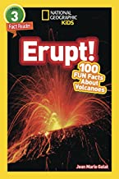
It would be fabulous if you could read some books linked to our topic ‘Natural Disasters.’ What can you discover about the major natural disasters? Are there any famous ones? Can you think of a different version to a story that you share? Who is your favourite character in the story and why? Below, are some suggestions of books that you might like to share at home:
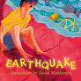
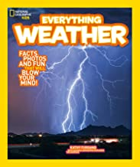
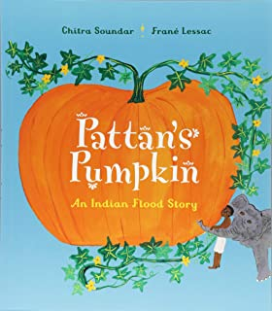
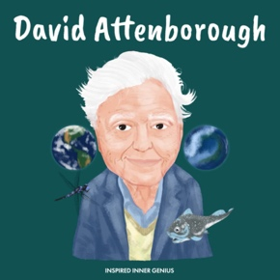
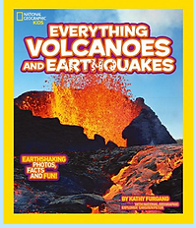

Literacy & English:
You might like to watch a children’s news report of a natural disaster and write a summary of the main events in the news report. You could create a poem about a natural disaster, possibly in the format of an acrostic poem? Or maybe you could make a poster for a humanitarian aid agency who help when a natural disaster happens, remembering to use persuasive language to ask for support.

Expressive Arts:
Explore artwork inspired by a natural disaster (such as earthquakes, droughts and floods) and create a piece of art that reflects a natural disaster of your choice. How about designing a survival kit that someone living in a high-risk area might need? Act out a news report of a natural disaster, performing it to an audience at home ready to share in class. Can you design a device to warn of natural disasters?

Junk modelling creation:
Make a model of a natural disaster scene. There are plenty to pick from; you could focus upon earthquakes, volcanic eruptions, hurricanes, tsunamis, floods, wildfires and droughts.

Research:
You could research fault lines, mark them on a world map and explain where the ‘high-risk’ countries are for potential earthquakes. Try locating the site of natural disasters on a map. What can you find out about a famous natural disaster? Share this research in a
creative way. Talk with someone at home about the impact a natural disaster can have on the people and the landscape. How are buildings in high-risk areas adapted to be earthquake-proof?

Maths
Try to calculate the approximate cost of replacing all of your belongings. Can you research natural disasters and then represent your research as a pictogram, tally chart or bar graph to show your findings?

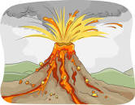
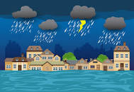
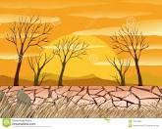
It would be super if you complete at least one activity and bring it into school on Monday 18th July, so that we can enjoy sharing these in class throughout the week. Any questions please do not hesitate to ask.
Your continued support is greatly appreciated.
Many Thanks, Mrs Bedford and Mrs Bennett

