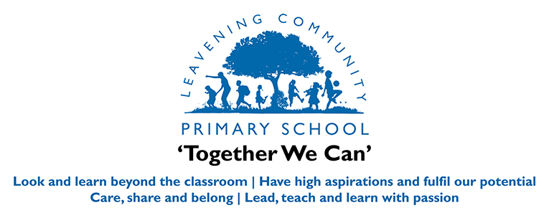
What were our main achievements in 2021-22?
- We are self-evaluating Leavening Community Primary School as a ‘good’ school in line with the Ofsted evaluation schedule.
- Leadership, at all levels, has driven rapid improvement. A strong governing body is in place.
- Our recovery curriculum (post pandemic) has enabled pupils to develop academic resilience and has supported their emotional health and well-being.
- Developed effective teaching and learning of phonics in Early Years Foundation Stage and Years 1 and 2 through our new scheme.
- Significantly improved engagement of pupils in reading for enjoyment across the whole school.
- Rapidly and significantly improved the classroom indoor and outdoor learning environments for EYFS and Ks1 pupils in acorns and conkers class.
- Placed a greater importance on the opinions of pupils in improving our school.
- Implemented a new writing cycle approach to teaching writing, to ensure better progress.
- Continued to implement and embedd a balanced and creative curriculum that excites our pupils.
- Ensured rich opportunities for pupils across the whole curriculum, including engagement in learning through visits, speakers and visitors to school.
- Improved pupils personal development opportunities through introduction a new Personal, Social, Health Education curriculum.

What are we developing in 2022-23?

- Develop ‘Talk through the day’ and ‘Talk through story’ sessions to further develop language and vocabulary in EYFS and KS1

- In KS2 we will improve pupils use of vocabulary across the whole curriculum.

- To develop mastering number in EYFS and KS1.

- To further develop retrieval practice strategies so pupils, retain knowledge better.

- To develop our home learning policy so it focuses on supporting pupil’s retention of knowledge.

