MATHS POLICY

Member of staff responsible: Jane Price
Link Governor responsible: David Griffin
Approved by Governors on: 04.10.22
Review Date: Oct 2024
Headteacher: Sian Mitchell
Chair of Governors: James Robinson

Curriculum Statement
Intent
The National Curriculum for mathematics aims to ensure that all pupils:
•become fluent in the fundamentals of mathematics, including through varied and frequent practice with increasingly complex problems over time, so that pupils develop conceptual understanding and the ability to recall and apply knowledge rapidly and accurately.
•reason mathematically by following a line of enquiry, conjecturing relationships and generalisations, and developing an argument, justification or proof using mathematical language.
•can solve problems by applying their mathematics to a variety of routine and non-routine problems with increasing sophistication, including breaking down problems into a series of simpler steps and persevering in seeking solutions.
At Leavening Primary School, these skills are embedded in Maths lessons and are developed consistently over time. We are committed to ensuring that children have a positive attitude towards Maths and that they are engaged and show curiosity about the subject. We ensure that all children recognise the importance of Maths in other areas of the curriculum and in the wider world so that they are also able to use their mathematical skills and knowledge confidently in their lives in a range of different contexts. We want all children to enjoy Maths and to experience success in the subject, with the ability to reason mathematically. This is made possible through providing opportunities for children to build a conceptual understanding before applying their knowledge to everyday problems and challenges.
Implementation
The content and principles underpinning the 2014 Mathematics curriculum and the curriculum at Leavening convey how our curriculum is implemented.
•Teachers reinforce an expectation that all children are capable of achieving high standards in Mathematics.
•Most of the children progress through the curriculum content at the same pace. Differentiation is achieved by emphasising deep knowledge and through individual support and intervention.
- It is the aim for children to be taught, as often as possible by the class teacher during each week. The Mixed Age White Rose units of work are blocked together, for the most part, to enable this to happen. Therefore, teachers endeavour to begin teaching the lesson with all children in the class or at the very least two year groups, with independent work then tailored to the year group. Where this becomes less possible, on occasions, a year group may be taught via a WR on-line teaching video with support from a teaching assistant.
•Teaching is underpinned by methodical curriculum design and supported by carefully crafted lessons and resources to foster deep conceptual and procedural knowledge. The teacher ensures that at the planning stage, the opportunities to work with as many
•Practice and consolidation play a central role. Carefully designed variation within this builds fluency and understanding of underlying mathematical concepts.
•Teachers use precise questioning in class to test conceptual and procedural knowledge and assess children regularly to identify those requiring intervention, so that children have the best possible opportunity to keep up. To ensure consistency and progression, Leavening follows the Mixed Age White Rose Maths scheme – teaching for mastery principles underpin this. The scheme follows a blocked approach to the teaching of Maths. This ensures that children can focus for longer on each specific area to develop a more secure understanding over time. This approach is also designed to enable children to progress to a greater depth of understanding. Subsequent blocks continue to consolidate previous learning so that the children continually practise key skills and can recognise how different aspects of Maths are linked. For example, when children have completed a block which has enabled them to master the multiplication of two- digit-numbers, a subsequent block on area and shape might provide opportunities to use this understanding when calculating the area of shapes with two digit length and width dimensions. Within the scheme, each National Curriculum objective is broken down into fluency, reasoning and problem solving.
Fluency
Fluency comes from deep knowledge and practice. This is the first stage of pupils’ understanding. Fluency includes conceptual understanding, accuracy, rapid recall, retention and practice. The key to fluency is deep knowledge and practice and making connections at the right time for a child.
Reasoning
Reasoning demonstrates that pupils understand a mathematical concept.
Talk is an integral part of mastery as it encourages children to reason, justify and explain their thinking. As such, this is an integral part of each lesson at Leavening Primary.
Problem-Solving
Mathematical problem solving is at the heart of the mastery approach. Pupils are encouraged to identify, understand and apply relevant mathematical principles and make connections between different ideas. This builds the skills needed to tackle new problems, rather than simply repeating routines without a secure understanding. Mathematical concepts are explored in a variety of representations and problem-solving contexts to give pupils a richer and deeper learning experience. Pupils combine different concepts to solve complex problems and apply knowledge to real life situations. Each lesson phase provides the means to achieve greater depth, with more able children being offered rich and sophisticated problems, as well as exploratory, investigative tasks, within the lesson as appropriate. To ensure that children reach a deep and sustainable understanding, we use concrete pictorial and abstract representations.
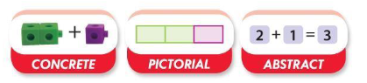

Concrete
Concrete is the doing stage, using concrete objects to model problems. Instead of the traditional method of mathematics teaching, where a teacher demonstrates how to solve a problem, the CPA approach brings concepts to life by allowing pupils to experience and handle physical objects themselves. Every new abstract concept is learned first with a concrete or physical experience. For example, if a problem is about adding up four baskets of fruit, the pupils might first handle actual fruit before progressing to handling counters or cubes which are used to represent the fruit.
Pictorial
Pictorial is the seeing stage, using representations of the objects to model problems. This stage encourages pupils to make a mental connection between the physical object and abstract levels of understanding by drawing or looking at pictures, circles, diagrams or models which represent the objects in the problem. Building or drawing a model makes it easier for pupils to grasp
concepts they traditionally find more difficult, such as fractions, as it helps them visualise the problem and make it more accessible.
Abstract
Abstract is the symbolic stage, where pupils can use abstract symbols to model problems. Only once a child has demonstrated that they have a solid understanding of the concrete and pictorial representations of the problem, can the teacher introduce the more abstract concept, such as mathematical symbols. Pupils are introduced to the concept at a symbolic level, using only numbers, notation, and mathematical symbols, for example +, –, x, ÷to indicate addition, subtraction, multiplication, or division.
Impact
Leavening Primary has a supportive ethos and our approaches support the children in developing their collaborative and independent skills, as well as empathy and the need to recognise the achievements of others. Regular and ongoing assessment informs teaching, as well as intervention, to support and enable the success of every child. These factors ensure that we can maintain high standards, that all children have a positive attitude towards Maths, that children are engaged and that children show curiosity about the subject.

Teaching and Learning Organisation
Mastering of Number
Children in Reception, Year 1 and Year 2 have a daily Mastering of Number teacher-led session of 10 -15 minutes, designed to ensure that pupils develop fluency with, and understanding of, number that is crucial to future success in maths and academic progress more generally. Mainly focused on: subitising; cardinality and counting; understanding the composition of numbers; quick recall of number bonds to 10 and 20; and 2, 5 and 10 x table by the end of Year 2.
This takes place outside the hour allocated to daily Maths lessons. The Mastering Number Programme is wholly consistent with teaching for mastery.
Running concurrently with this, KS2 undertake a 10-15 minute fluency of number fact session focusing on multiplication tables and related division facts.
The Maths lesson
A typical Maths lesson lasts one hour (excluding the Mastering of Number session). Maths is taught daily during the morning, apart from Fridays. All lessons start with ‘Flashback 4’, from the White Rose, which encourages children to revisit learning. This may alternatively be undertaken as an early morning work task. The first question is likely to be something children did in the previous lesson. The next question is something they did last week, to keep ticking over. The third and fourth questions are related to concepts which they studied last month, or maybe much earlier in the year (or even the previous year).
Following this, the main part of the lesson begins. Questions are carefully crafted to develop children’s fluency, reasoning and problem-solving skills and to develop a conceptual understanding for mastery. Teachers use careful questioning to draw out discussion and to encourage children to explain their reasoning. Children learn from misconceptions through whole class reasoning. Children will discuss problems with a partner or as part of a small group. Once the teacher is confident that the children are ready, they begin their independent work; the aim of this independent work is to build fluency and to develop greater understanding of underlying mathematical concepts. Extension tasks are always available for those who have completed their initial task. These tasks are usually reasoning based questions/ tasks which take the children’s understanding deeper. During the final part of the lesson, children reflect on their learning, enabling the teacher to gauge the depth of their understanding.
Correct teaching of relevant mathematical vocabulary is crucial; all adults should be modelling its usage and children consistently encouraged and praised for using the taught vocabulary.

Working Walls and Knowledge Organisers
These are an essential tool to support children’s learning at Leavening Primary. It is expected that the current vocabulary is displayed on the Maths Working Wall and the key elements of learning for the unit being studied, for each year group. The knowledge organiser for each unit will reflect the key learning, vocabulary and stem sentences. Children will have their own copy to be kept in their maths books which children use regularly as a support tool.
Assessment
Formative Assessment
Formative assessment is a feature of every lesson. Observations and careful questioning enable teachers to adjust lessons and brief other adults in the classroom where necessary. Children receive effective feedback regularly throughout the lesson where ‘live marking’ is a focus; the teaching sequence ensures that children know how to be successful in their independent work. At the end of a lesson, children review their work and self, and peer assessment are used consistently, as outlined by the school’s ‘Assessment and Feedback Policy’.
At the end of each block of work, children complete the White Rose end of unit assessment. The outcome of this is used by the teacher to ensure that any identified gaps in understanding can be addressed before the next unit is taught. Each child’s scores are also inputted into a spreadsheet, which provides an overview of achievement in each specific area within the programme of study.
Summative Assessment
Termly, teachers administer a White Rose arithmetic paper and reasoning and problem-solving paper which specifically link to coverage for that term. The results of these papers are used to identify children’s ongoing target areas. Both the end of unit assessments and the end of term assessments are used to inform the whole school tracking of attainment and progress for each child, on a half-termly basis (OTrack). Assessment data is reviewed throughout the year to inform interventions and to also ensure that provision remains well-informed to enable optimum progress and achievement. End of year data is used to measure the extent to which attainment gaps for individuals and identified groups of learners are being closed. This data is used to inform whole school and subject development priorities for the next school year.
Planning and Resources
Lessons are based on the White Rose mixed age scheme of work, which follows the National Curriculum. Planning should aim for all pupils to master the age group expectations of the National Curriculum by including rich, deep activities. Rapid graspers should not be accelerated through concepts, instead they should complete challenge questions from NCETM and White Rose. The yearly overview provides a long-term plan and is arranged into blocks.
Year 1/2 Yearly Overview

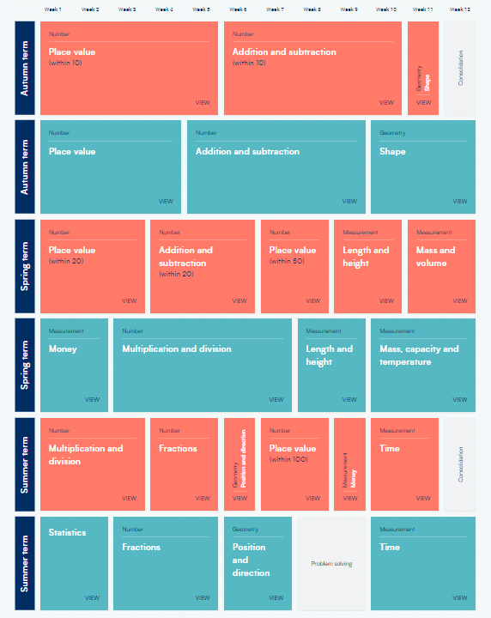
Resources

The use of resources is integral to the concrete-pictorial-abstract approach and is therefore carefully planned into teaching and learning. School has a wide variety of good quality equipment and resources, which are mainly stored in each classroom, to support teaching and learning. Teachers ensure that these are readily available for the children to use to support their own learning.
These resources are used by teachers and children in a number of ways including:
•Demonstrating or modelling an idea, an operation or a method of calculation.
•Enabling children to use a calculation strategy or method that they couldn’t do without help, by using any of the resources as required. Teachers are encouraged to use the school playgrounds as an outdoor classroom when possible, for example, when teaching length, area or perimeter.

EYFS
Teaching and learning:
The Mathematics curriculum in Early Years and Foundation Stage is split into two categories: numbers, and shape and space and measure. At Leavening Primary School, in EYFS, children learn Maths through teachers teaching the main skills through focused activities, play and their daily experiences. We try to make their experiences as meaningful to them and as hands on as possible to enable them to develop. We ensure that the indoor and outdoor continuous provision is full of mathematical opportunities and that there are exciting things for children to explore, sort, compare, count, calculate and describe. We support them in being creative, critical thinkers, problem solvers and willing to have a go. During the children’s time in Reception, teachers use the White Rose scheme within their teaching to support Maths delivery and to ensure that the children are grounded ready for when they start learning in Year 1. Children take part in a daily Mastering of Number session – this takes place in the Nursery classroom, so all children in our EYFS are exposed to this learning and have the opportunity to participate.
Assessment
We collect evidence from activities and observations and we differentiate work accordingly. The children’s achievements are on-going and are assessed against the Early Learning Goals.
The EYFS Framework (2021) highlights the importance of assessing what children understand, know and can do in a variety of contexts. This assessment process is best done through observation and discussion. Practitioners can only see the true depth of children’s mathematical enquiries and learning through close observation. This is especially true where the attainment demonstrated is not dependent on adult support. Sustained shared thinking is a positive means of assessing children and by listening carefully to their responses and considering the right questions to ask, it helps to reveal children’s understanding. Information gained through observing children and talking to them, should be used to inform next steps for teaching. This needs to build on what children already know and can do. Practitioners should consider developmental progression, using tools such as the revised Development Matters (2020) and Birth to 5 Matters (2021) as these will be useful in informing decisions about what children should learn next. The focus should be on supporting children to develop a deep rather than a superficial understanding of mathematical concepts. Because of this, it is important to provide children with lots of opportunities to practise and consolidate their learning in different contexts.
Planning
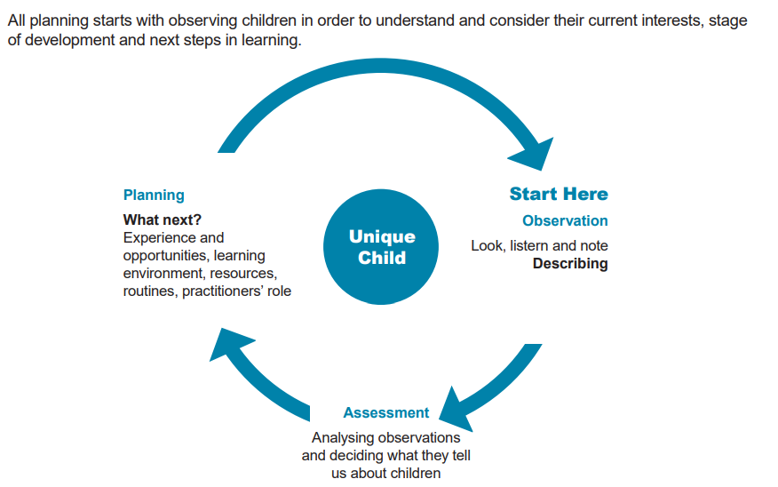
Equal Opportunities
We are committed to ensuring the active participation and progress of all children in their learning. All children are given equal opportunities to achieve their best possible standard, whatever their current attainment and irrespective of gender, ethnic, social or cultural background, home language or any other aspect that could affect their participation or the progress which they are capable of.
Inclusion
Taking a mastery approach, differentiation occurs in the support and intervention provided to different children, not in the topics taught, particularly at earlier stages. The National Curriculum states: ‘Children who grasp concepts rapidly should be challenged through being offered rich and sophisticated problems before any acceleration through new content. Those who are not sufficiently fluent with earlier material should consolidate their understanding, including through additional practice, before moving on.’ There is little differentiation in the content taught but the questioning and scaffolding individual children receive in class as they work through problems will differ, with higher attainers challenged through more demanding problems, which deepen their knowledge of the same content before acceleration onto new content. Children’s difficulties and misconceptions are identified through immediate formative assessment and addressed with rapid intervention-commonly through individual or small group support later the same day, or as soon as possible thereafter. A range of inclusion strategies are embedded in practice and teachers are aware of the special educational needs of the children in their classes, as well as those who have English as an additional language. Although the expectation is that the majority of children will move through the programmes of study at broadly the same pace, the 2014 National Curriculum states: ‘Decisions about when to progress should always be based on the security of children’s understanding and their readiness to progress to the next stage.’ If a child’s needs are best met by following an alternative plan, including coverage of the content from a previous year, this will be overseen by the SENDCo, in collaboration with the class teacher. Specific arrangements for the provision of children with SEND will be communicated to parents and carers during SEND reviews.’

Role of the Subject Leader
The subject leader will:
- raise the profile of Maths at Leavening Primary School through best practice. They will model lessons, as appropriate, to new staff, NQTs and colleagues to support continued professional development.
- ensure the high quality of Maths displays around the school and involve the school in ‘celebrations’ of Maths, including Maths Week and National Numeracy Day. The subject leader will support staff in providing opportunities for learning outside the classroom in Maths and will identify and organise opportunities which enable this, as appropriate.
- will monitor progression and continuity of Maths throughout the school through lesson observations and regular monitoring of outcomes of work in books.
- will ensure that all staff have access to year group plans and the relevant resources which accompany them.
- monitor children’s progress through the analysis of whole school data. They will use this data to inform the subject development plan which will detail how standards in the subject are to be maintained and developed further.
- organise, audit and purchase Maths resources.
- keep up to date on current developments in Maths education and disseminate information to colleagues.
- extend relationships and make contacts beyond the school.
- develop opportunities for parents/carers to become more involved in Maths education.
- ensure that all staff have access to professional development including observations of outstanding practice in the subject.

Parents
The school recognises that parents and carers have a valuable role to play in supporting their child’s mathematical learning. The Mathematics Policy, Calculation Policy and long-term plans are available on the school’s website. Paper copies of these documents are also available on request.
The school provides opportunities for parents/carers to learn about what their child is learning and the way their child is being taught through parent workshops.
Children are given Maths homework organised by the teacher based on Maths knowledge organisers for each unit of work from Year 1 to Year 6. This is sent home in the children’s homework book with the homework activity.
Parents are informed of their child’s progress at Parents’ Consultation Evenings and through the end of year written report.

