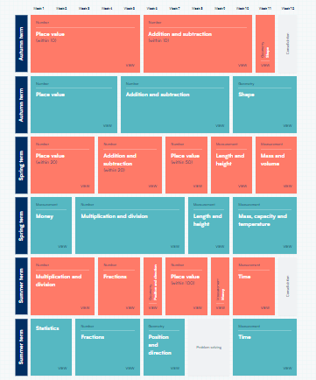

**KS1 Maths Curriculum Map**