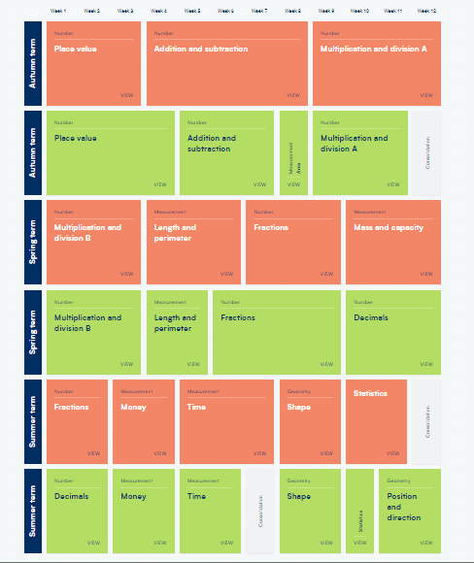

**Year 3 and 4 Maths Curriculum Map**

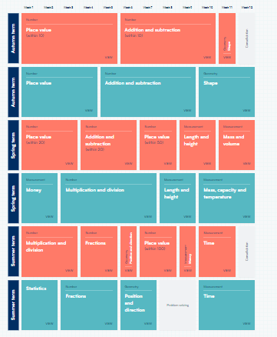

**Year 3 and 4 Maths Curriculum Map**