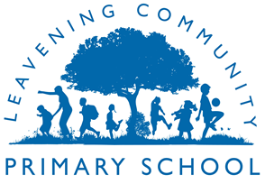

Leavening Community Primary School
COVID Catch up premium report: 2022-23
Overview of the school
Total number of pupils currently on roll for Academic Year 22/23 | 43
Total number of pupils eligible for Covid catch up funding | 4
Total amount of SPF received for Financial Year 22/23 | ££2000 recovery premium  £486 school led tutoring
Curriculum focus of CCF spending 2022-23 (From January 2023)
- Talk through stories and Little Wandle SEND programme and additional hours for teaching assistant to carry this out each day for pupils in EYFS
- Covid Catch up intervention plan put in place for disadvantaged pupils in KS2.
The impact of this spending:
EYFS
60% of pupils have achieved a good level of development in EYFS
83% of pupils have passed the Phonics Screening Check
80% of pupils have achieved expected standard in language and communication across the EYFS
The use of vocabulary in pupil’s speech as well as writing has improved across 2022-23.

KS2
Individual case studies show that the targeted pupils have made good value added progress in reading in their KS2 tests.
All pupils have made progress from their starting points across tutoring in the core subjects.
Attendance has improved from 82.9% this time last year ( June 2022) to 96.9% ( June 2023)
Persistent absent pupils has decreased from 16 ( June 2022) to 4 ( June 2023)
Pupils self esteem has increased as a result of the tutoring and they are therefore more engaged in their learning and the curriculum.

