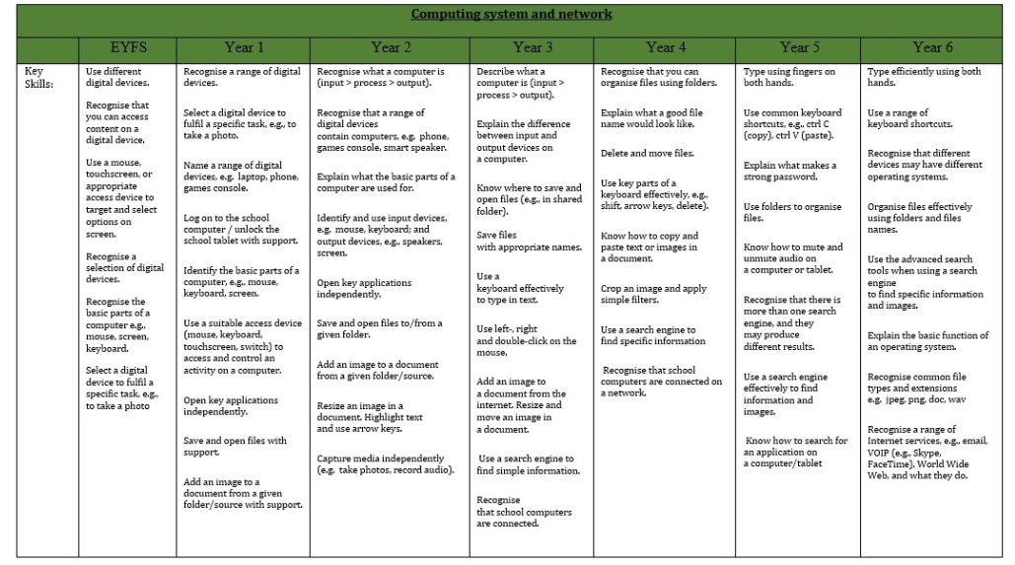**Computing Progression of Knowledge and Skills at Leavening Primary**

