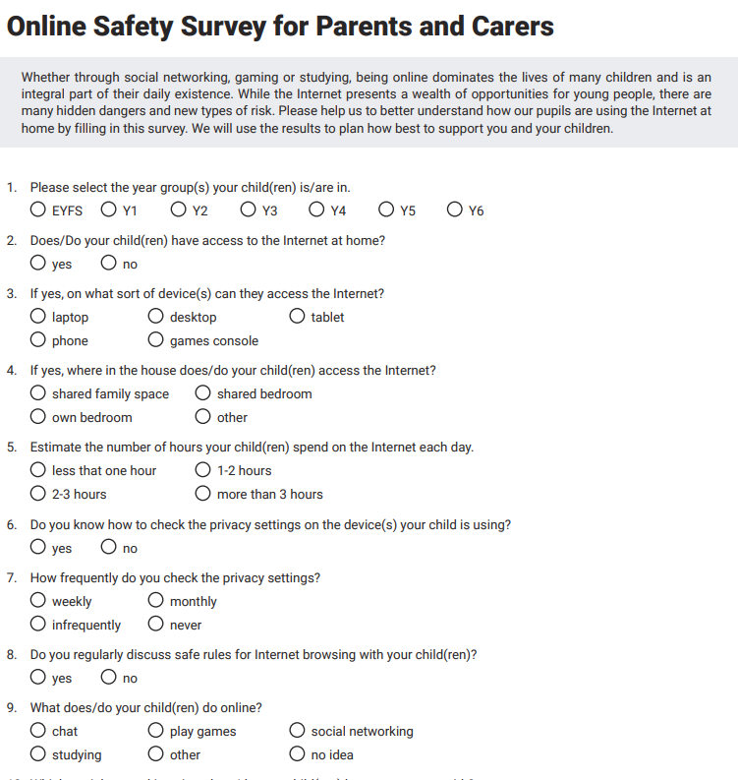
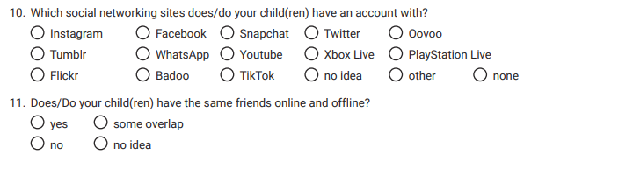
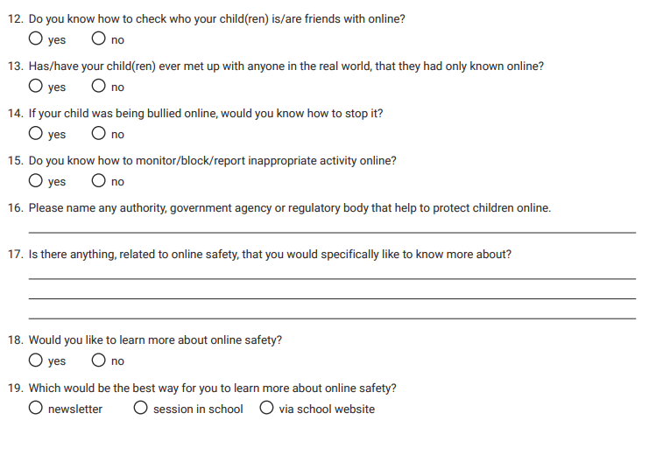

Thank you for taking time to participate in this survey. This enables us to tailor our online safety curriculum to meet the needs of our children and their families. It also enables us to ensure that we provide the right support for parents and carers in a time where online communities are becoming more prominent in your children’s lives.

