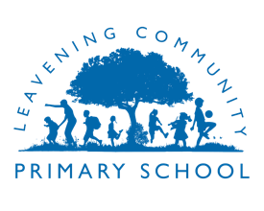
Leavening Community Primary School
Religious Education Subject Overview
(Taken from North Yorkshire Agreed Syllabus for RE 2019-2024)

Principal Aim:
‘The principal aim of RE is to engage pupils in systematic enquiry into significant human questions which religion and worldviews address, so that they can develop the understanding and skills needed to appreciate and appraise varied responses to these questions, as well as develop responses of their own.’

Progression of Skills for EYFS
RE in Nursery | RE in Reception
Activities children engage in during their nursery years are experiences which provide the building blocks for later development. Starting with things which are familiar to the children, and providing lots of hands-on activities and learning are an important part of pupils’ learning at this stage.  Some ideas for Religious Education in the nursery can include:  • Creative play, make-believe, role play, dance and drama  • Dressing up and acting out scenes from stories, celebrations or festivals  • Making and eating festival food  • Talking and listening to each other; hearing and discussing stories of all kinds, including religious and secular stories with themes such as goodness, difference, the inner world of thoughts and feelings, and imagination  • Exploring authentic religious artefacts, including those designed for small children such as ‘soft toy’ artefacts or story books  • Seeing pictures, books and videos of places of worship and meeting believers  • Listening to religious music  • Starting to introduce religious terminology  • Work on nature, growing and life cycles or harvest  • Seizing opportunities spontaneously or linking with topical, local events such as celebrations, festivals, the birth of a new baby, weddings or the death of a pet  • Starting to talk about the different ways in which people believe and behave, and encouraging children to ask questions.  Good teaching in the EYFS will always build on children’s interests and enthusiasms as well as their learning and development needs, and themes should be developed accordingly.  Themes which lend themselves to opportunities for RE work include the following:  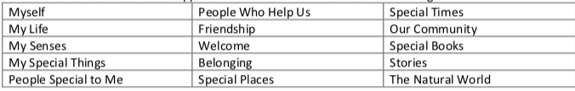 | (Non-statutory guidance for RE for all 4–5 year olds in Reception)  Strands: Foundation Stage: Discovering the world  Believing (Religious beliefs, teaching, sources; questions about meaning, purpose & truth)  F1 Which stories are special and why?  F2 Which people are special and why?  Expressing (Religious & spiritual forms of expression; questions about identity & diversity)  F3 What places are special and why?  F4 What times are special and why?  Living (Religious practices & ways of living; questions about values & commitments)  F5 Being special: Where do we belong?  F6 What is special about our world?
RE in KS1
Strands: KS1: Exploring
Believing (Religious beliefs, teaching, sources; questions about meaning, purpose & truth)
  - Who is a Christian and what do they believe?
  - Who is a Muslim and what do they believe?
  - Who is Jewish and what do they believe?
  - What can we learn from sacred books?

Expressing (Religious & spiritual forms of expression; questions about identity & diversity)
1.5 What makes some places sacred?
1.6 How and why do we celebrate special and sacred times?

Living (Religious practices & ways of living; questions about values & commitments)
1.7 What does it mean to belong to a faith community?
1.8 How should we care for others and the world, and why does it matter?
RE in Lower KS2
Strands: Lower KS2: Connecting
Believing (Religious beliefs, teaching, sources; questions about meaning, purpose & truth)
L2.1 What do different people believe about God?
L2.2 Why is the Bible so important for Christians today?
L2.3 Why is Jesus inspiring to some people?

Expressing (Religious & spiritual forms of expression; questions about identity & diversity)
L2.4 Why do people pray?
L2.5 Why are festivals important to religious communities?
L2.6 Why do some people think that life is a journey and what significant experiences mark this?

Living (Religious practices & ways of living; questions about values & commitments)
L2.7 What does it mean to be a Christian in Britain today?
L2.8 What does it mean to be a Hindu in Britain today?
L2.9 What can we learn from religions about deciding what is right and wrong?

RE in Upper KS2
Strands: Upper KS2: Connecting
Believing (Religious beliefs, teaching, sources; questions about meaning, purpose & truth)
U2.1 Why do some people believe God exists?
U2.2 What would Jesus do? Can we live by the values of Jesus in the twenty-first century?
U2.3 What do religions say to us when life gets hard?

Expressing (Religious & spiritual forms of expression; questions about identity & diversity)
U2.4 If God is everywhere, why go to a place of worship?
U2.5 Is it better to express your beliefs in arts and architecture or in charity and generosity?

Living (Religious practices & ways of living; questions about values & commitments)
U2.6 What does it mean to be a Muslim in Britain today?
U2.7 What matters most to Christians and Humanists?
U2.8 What difference does it make to believe in ahimsa (harmlessness), grace, and/or Ummah (community)?

RE Progression of Skills Overview for KS1 & KS2
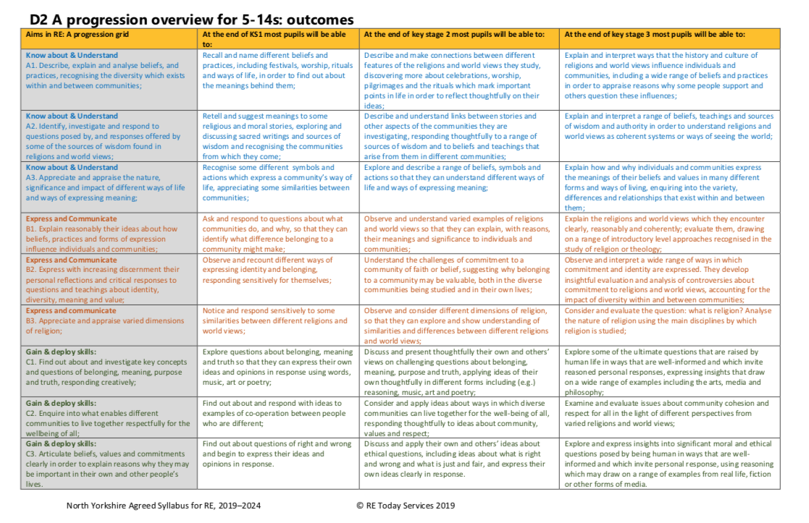

Threshold Concepts for RE
Investigating Beliefs Believing (Religious beliefs, teaching, sources; questions about meaning, purpose & truth)

Exploring Spiritual Expression Expressing (Religious & spiritual forms of expression; questions about identity & diversity)

Understanding ways of Living Living (Religious practices & ways of living; questions about values & commitments)

Types of (interconnected) Knowledge
Pillars of Progression within RE
There are three different types of knowledge used in RE, which are pillars of progression.
Substantive knowledge:
Pupils learn subject content about various religious and non-religious traditions.
Ways of knowing:
Pupils learn ‘how to know’ about religion and non- religion.
Personal knowledge:
Pupils build an awareness of their own presuppositions and values about the religious and non-religious traditions they study.
Substantive knowledge: knowledge about various religious and non-religious traditions:
Substantive content includes: different ways that people express religion and non-religion in their lives, including diverse lived experiences and the complexity of the fluid boundaries between different traditions; knowledge about artefacts and texts associated with different religious and non-religious traditions; concepts that relate to religious and non-religious traditions, such as ‘dharma’, ‘incarnation’, ‘ritual’, ‘authority’, ‘prayer’, ‘sacred’, ‘anatta’ and ‘moksha’; the very concepts of ‘religion’ and ‘non-religion’ and debates around these ideas.

Ways of knowing: pupils learn ‘how to know’ about religion and non-religion: ‘Ways of knowing’ is about being scholarly in the way that substantive content and concepts are approached. It refers to the different ways that pupils learn how it is possible to explore that substantive knowledge. With only substantive (‘what to know’) knowledge, the RE curriculum would be incomplete because pupils also need to learn ‘how to know’ in RE. Pupils are prepared to think in critical and scholarly ways about the representations of religion and non-religion that they learn through the curriculum and encounter in the world beyond. There seem to be 2 main forms of ‘ways of knowing’ that pupils can learn in the curriculum:
- knowledge of well-established methods and processes and other tools of scholarship that are used to study and make sense of global and historical religion/non-religion
- knowledge of the types of conversation (or ‘modes of enquiry’ or ‘scholarly discourses’) that academic communities have about religion/non-religion
- These 2 forms have sometimes been referred to as ‘disciplinary knowledge’ in RE
Personal knowledge: pupils build an awareness of their own presuppositions and values about the religious and non-religious traditions they study: Personal knowledge has been described by various educators as ‘knower-knowledge’, ‘personal worldview’, ‘reflexivity’ and ‘positionality’. When pupils study RE content, they do so ‘from a position’. This position is their ‘viewpoint’ or perspective on the world, which is influenced by, for example, their values, prior experiences and own sense of identity. Pupils build ‘personal knowledge’, which includes an awareness of the assumptions that they bring to discussions concerning religious and non-religious traditions. The focus on both knowledge of religious traditions and also what that knowledge contributes to the pupils’ self-understanding.
*Taken from the ‘Ofsted Research Review Series: Religious Education (May 2021)’
Progression of Vocabulary for EYFS
*Key Progression of Vocabulary features in yellow
Nursery | Reception
Religion, Religious, Non-religious, Special, Special books/stories, Religious stories, Religious objects/artefacts, Religious music, Special places, Places of worship, Special things, Special people, Special times, Help/helpful, Friendship, Welcome, Myself, Rules, Belonging, Belong, Belief, Believe, Believers, Behaviour, Behave, Questions, Goodness, Difference, Same, Thoughts, Feelings, Imagination Christmas, Easter, Harvest, Jesus, God, Church, Christian, Vicar, Priest, New-life, Relationships, Friend, Family, Community, Memory, Prayer, Love, Thankful, Celebration, Festival, Festival food, Valentine’s Day, Shrove Tuesday, Lent, Holi, Mother’s Day, Father’s Day, Good Friday, Easter Sunday, Diwali, Chinese New Year, Lunar New Year, Guy Fawkes Night, Remembrance Day, Black History Month, Halloween, Hannukah, Advent, Christmas Eve, Christmas Day, New Year’s Eve, New Year, Nature, Growing, Life cycles, Life, Death, The natural world, Senses. | EYFS  F.1 Special stories/books, religious stories, secular stories, favourite story/book, re-telling, Jesus, God, Bible, Bible stories, Christians, faith, similarities/differences, feelings, beliefs, Believe, Qur’an, sacred text, promises, holy book, faith, traditions, cultures, leaders/founders of faiths, Muslim, Prophet Muhammed, Diwali, Hindu, Diwali, Rama, Sita, Diva lamp, celebration, Jewish people, Torah  F.2 People, special, special people, good friend, friends, family, relative, friendship, qualities, admire, stories, God, Jesus, caring, helpful, kind, loving, thankful, giving thanks, religions, religious, non-religious, stories of Jesus, Bible, Jesus, twelve disciples, helpers, helping, healing, miracle, Religious leader, Guru Nanak, Prophet Muhammad, the Buddha.  F.3 Place, special, special place/s, feel, safe, happy, believers, religious people, special meaning, valued, place of worship, worship, pray/prayer, thoughts, feelings, spiritual, memories, senses, meaningful, significant, Christian, Christians, Church building, Holy, Minister, Vicar, Reverend, Steeple, Font, Altar, Pew, Cross, Stained Glass Window, Muslims, Mosque, Mecca (Makkah), Allah, Jewish people, Synagogue, reflection.  F.4 Times, special times, celebrate, celebration, celebrating, Christmas, Easter, Jesus’s birth/death, Christians, festivals, stories, similarities/differences, occasions, importance, value, invitations, special days, birthday, wedding, christening, Christmas, Mother/Father’s Day, religious festivals, Sukkoth, Eid-ul-Adha, Diwali, religious believers.  F.5 Belong, respect, love, loved, care, cared for, feeling, welcome, togetherness, special, welcomed, re-tell religious stories, occasions, Christian, Christianity, Infant Baptism, Dedication, blessing, unique, valuable, religious beliefs, God, loving, palm, Jesus, Disciples, Faith, Islam, Asqiqah ceremony, Humanist, naming ceremony, signs and symbols, Baptismal candle, Hinduism, stories, Hindus, Raksha Bandhan, Rakhi, Aum, special bond, brothers and sisters.  F6 Special, world, our world, nature, favourite thing, best of all, stories of creation, Creator, Christians, care for, look after, similarities/differences, ideas, interesting, puzzling, wonderful, feelings, God, human beings, wonders, beauty, natural world, expressing ideas/feelings, animals, plants, mess up the world, look after the world, growth, decay, cycles of new life, Beginning, Muhammed, Muslim.
Progression of Vocabulary for KS1
*Key Progression of Vocabulary features in yellow
  - Christian, Christianity, believe, belief, believer, God, religion, Jesus/son of God, exists, God’s existence, Christian symbols, express ideas, good, bad, right, wrong, miracle, Lord’s Prayer, Forgive, Temptation, Sin, Heaven, stories, Bible, Old Testament, Jesus’s teachings, Christian beliefs, Pentecost, being thanked, praising, being praised, worship
  - Muslim, believe, believing, Allah, Islam, Muhammad, Prophet, Peace Be Upon Him (PBUH), Prophet Muhammed, Ramadan, Eid-ul-Fitr, prayer beads, prayer mat, celebrate, Inspired, Crescent, Star, Calligraphy, 99 Names of Allah, Holy Qur’an, Nasheed, Arabic, Mosque, Masjid Imam, Prayer Mat, Wudu, Dome, Minaret, Shahadah, Call to Prayer, Revelation, Angel Jibril, Mount Hira, Arabic Teachings, Beliefs, Precious
  - Jewish person, Jewish, believe, believing, God, G-d, star of David, meaning, symbol, scroll, Shema, Mezuzah, Shabbat, candles, blessing, challah bread, Dreidel, oil, kippah, Sukkoth, Chanukah, Pesach, menorah, 9 branched Chanukiah, Torah, Hebrew, synagogue, Rabbi, Challah, Seder meal, teachings
1.4 Sacred books/texts, believing, believe, stories, Secular books, Christians, Muslims, Jewish people, good/bad, right/wrong, significance, parable, differences/similarities, meaning, special, holy, God, Bible, Muslims, Holy Qur’an, Prophet Muhammed, Jewish people, Tenakh, used/treated, Torah, scrolls, yad, ark, Hebrew, synagogue, Hebrew, accessible, Muslim, Islam, Qu’ran, Allah, Muhammad, Mount Hira, Arabic, Prophet, Message, Problem, Solution, Teamwork, Trustworthy
1.5 Places, scared, Holy, respect, similarities/differences, sacred places, special places, worship, objects, religions, meaning, meaningful, stories, objects, symbols, artefacts, actions, churches, mosques, synagogues, believe/belief, worship God, expressing, symbols, church – altar, cross, crucifix, font, lectern, candles, symbol of light, icons, stations of the cross, pulpit, Sacred, Holy Week,
worship, Pray/Prayer, Church, Symbol, Holy Week, Good Friday, Crucifixion, Tomb, Easter Sunday, Resurrection, Jerusalem, Palm Sunday, Last Supper, Betrayal, Arrested, Synagogue – ark, Ner Tamid, Torah scroll, tzitzit (tassels), tefillin, tallit (prayer shall), kippah (skullcap), hanukkiah, Mosque – wudu, prayer mat, prayer beads, minbar, mihrab, muezzin, Holy, Sacred, Hymns Denial, Mosque/Masjid, Wudu, Calligraphy, Prayer mat, Prayer beads, Minbar, Mihrab, Muezzin
1.6 Celebrate, special, scared times, stories, meanings, expressing, celebrate, Jesus, Christians, son of God, Christmas, Easter, Harvest, Pentecost, festival, important, believers, symbols, actions, Chanukah, Muslims, Eid-ul-Fitr, fasting (Ramadan), Easter, light and joy, Palm Sunday, Temple, Last Supper, Jesus, Disciples, Jerusalem, Holy week, Good Friday, arrested, Crucifixion, resurrection, Easter Sunday, Palm Sunday, Last Supper, Betrayal, Arrested, Denial, Tomb, Resurrection, Fasting Jews, Judaism, Pesach, Passover, Moses, Exodus, Slave, Pharaoh, Plague, Seder, matzah, Harvest, Thankful, Christmas, Chanukah, light, symbol, communities, Celebrate, Festival, Decoration, Symbol, Joy, Meaning, Advent, Nativity, Innkeeper, Stable, Manger, Shepherd, Angel Gabriel, Saviour, Wise men, Gold, Frankincense, Myrrh, Carol, Bethlehem, Hanukkah, Menorah, Miracle, dreidel, decoration, rejoicing, weeping
1.7 Faith, religion, rule, identity, community, Judaism, Christianity, families, school, belonging, living, special, value, important, awareness, symbols, symbols of belonging, Christians, believers, Baptism, Baptismal candles, Christening, Cross, charity, Crucifix, Rosary, WWJD, ICHTHUS, fish/ICHTHUS badge, christening clothes, badges, necklaces, what would Jesus do bracelets, WWJD, welcome, Ceremony, dedication, actions, married, marriage, promises, hymns, prayers, co-operation, express, identity, faith communities, similarities/differences, Vicar, Holy Water, Font, White robe, Aqiqah, Calligraphy, Ka’ba, Hajj, Allahu Akbar, Razor, Scales, charity work, Christian Aid, Islamic Relief, Remembrance 11th November, Gold, Marriage/Wedding, Promises, Rings, Hava Nagila, Hebrew , Chuppah, Jewish Weddings, rings, gifts
1.8 Care, care for others, world, matters, living, religions, God, created the world, look after, care for, caring, Bible Stories, faith, Good and Bad/Right and Wrong, Golden Rule, Creation story – Adam and Eve, Unique, Important teachings, Values, Benefits, Responsibilities, Gifts, Serving, Alms, Samaritan, friendship, Jesu’s special friends, special gift, serving others, Zakat, Islam, Charity, Inspiration, Inspired, Judaism, Tzedakah (charity), Mother Theresa, Dr Barnardo, Sister Frances Dominica, Creation, Spoiled, Environment

Progression of Vocabulary for Lower KS2
*Key Progression of Vocabulary features in yellow
L2.1 People, different people, believe, God, Christians, Hindus, Muslims, sacred texts, faith, belief, similarities/differences, ideas, express, words, symbols, arts, trust, everyday lives, attributes of God, God as Trinity – Father, Son, Holy Spirit (Hindu), Trimurti – Brahma (creator), Vishnu (preserver), Shiva (destroyer) Murtis Pentecost, Religious, metaphors, Bhagavad Gita Ascension, 99 Names of Allah, Moses, Qur’an, Muhammad, Trust, Faith, Believing, Experience, Express ideas, Trinity, Father, Son, Holy Spirit, Love, Light, Creator, Listener to prayers, Faithfulness, Moses, Burning Bush, Saul St Paul, Conversion, Mystery, Shahadah, 99 Names of God, Subha Beads, Tasbih, Devotion, Reciting, Merciful, Revealed, Allah, Prophet Muhammed, Holy Qur’an, Peace be Upon Him (PBUH), Qur’an, Trimurti, Brahma – Creator, Vishnu – Preserver, Shiva – Destroyer, Similarities, Differences, Influence, Trimurti, Indescribable, Durga, Prism, Ultimate Reality, Humanism/Humanist, Freedom God as Trinity – Father, Son, Holy Spirit, (Hindu) Trimurti – Brahma (creator), Vishnu (preserver), Shiva (destroyer), Murtis, Pentecost, Religious metaphors, Bhagavad Gita, Ascension, Humanists, Atheists
L2.2 Bible, important, Christians, today, believing, bible stories, inspire, Christians, everyday life, fall salvation, humans, bad things, put things right, big story, rescue/save human beings, wisdom, Creation, incarnation, salivation, creation, The Fall, Salvation, Guidance, Wisdom, Old and New Testaments, Jewish scriptures – books, chapters and verse, Gospels, Incarnation, Temptation Forgiveness Sin/sinners, Guidance, Wisdom, Old Testament, New Testament, Books, Chapters, Verses, Gospels, Biographies, History, Law, Poems, Visions, Psalm, Apostles, Scripture, Big Story, Creation, The Fall, Temptation, Adam and Eve, Sinner, Save, Rescue, Disobey, Forgiveness, Reconciliation, Incarnation, Salvation, The World, Creation, The Fall, Salvation Guidance, God loves humans, wonderful world, God’s dealings, disobey God
L2.3 Christians, Jesus, believing, inspiring, inspirational, followers, celebrate, Parables, Easter, Easter story, creation, the Fall, incarnation, salvation, attitudes, values, Holy Week, Shrove Tuesday, Ash Wednesday, Maundy Thursday, Easter Sunday, Incarnation, Salvation, Resurrection, Holy Spirit, Sacrifice, gospel, incarnation, salvation, gratitude, caring for others, giving generously, Holy Spirit, fruit of the spirit, prayer, worship, love, fairness, service, sacrifice, joy
L2.4 Pray, expressing, believers, pray, religious believers, comfort, challenge, similarities/differences, Christians, Hindus, Muslims, significance, meaning, Holy Qur’an, First Surah of the Qur’an, Christian Lord’s Prayer, Hindu, Gayatri, Mantra, Spiritual, calm, hopeful, inspired, close to God, challenged, Atheists, Islam
L2.5 Religious, Festivals, celebrations, important, shared values, hopes, commitments, meaning, religious communities, expressing, rituals Eid Ramadan Eid-ul-Fitr Henna Charity Fasting Mehind, Christmas, Holy Week, Easter, Pentecost, Diwali, Pesach, Rosh Hashanah Yom Kippur Rituals, Symbols, Values, beliefs, Impact, Community, Express, Preserved, Sawm, Ramadan, Eid-ul-Fitr, Relief, Opportunity, Closer to God, Sacrifice, Obedient, Disciplined, Spiritual, Generous, Eid Ramadan, Eid-ul-fitr Henna Charity, Fasting, Mehndi
L2.6 Life, journey, significant experience, mark, expressing, milestones, commitment, promises, believers, Christian/Jewish/Hindu ceremonies of commitment, rituals, community, belonging, belief, similarities/differences, value, challenge, metaphor of life, Ceremony of commitment, responsibility, Christianity, confirmation, Baptism, First Communion, Confession, Sacred, Thread, Ceremony, Judaism, Bar/bat mitzvah, Chayil, Non-religions, Humanists, Humanism, Reincarnation, Heaven, Journey, Milestone, Metaphor, Signposts, map of life, Stopping Points, Traffic Jams, Responsibility, Ceremonies, Confession, First Holy Communion, Believer’s baptism, Sacred Thread, Holy Scriptures, Veda, Suffering, Spiritual Freedom, Sannyasa, Purify Bar, Bat Mitzvah, Commandment, Chayil, Promises, Commitment, Relationship, Marriage, Civil Partnership, Vows, Ketubah, End of Life, Life after death, Bhajans, Meditations, Milestones, Ceremony of commitment, Responsibility, Baptism, First Communion, Confession, Sacred, Thread ceremony, Bar/bat mitzvah, Chayil, Non-religions, Humanists/Humanism, Reincarnation, Heaven
L2.7 Christian, Britain, living, Roman Catholic, Pentecostal Sunday School St Vincent De Paul society Christians Against Poverty Christian Aid justice, Crucifix, Palm cross, verse, Grace, Crib, Advent candle/wreath, Christingle, Rituals, Hymn, Spiritual, Spontaneous, Formal, Holy Communion, Eucharist, Confirmation, Anglican, Catholic, Baptist, Pentecostal, Methodist, Messy Church, Sunday School Girls/Boys Brigade, Creche Foodbank, St Vincent de Paul, Alpha courses, Community, Justice/injustice, Rosa Parks, Civil Rights, Mother Theresa, Pope Francis, Archbishop Justin Welby, Loretta Minghella, Christian Aid, Anglican, Baptist, Roman Catholic, Pentecostal Sunday School, St Vincent De Paul society, Christians Against Poverty Christian Aid, justice
L2.8 Hindu, Britain, living, families, mandir, faith, express, beliefs, similarities/differences, Santana Dharma – Eternal Way Shrine Deities Puja tray – incense OM symbol, Bhagavad Gita, Aarti Bhajans, Dharma Karma Moksha, Reincarnation, Mandir Temple, Iconography, Santana Dharma – Eternal Way Shrine, Deities, Puja tray – incense, OM symbol, Bhagavad Gita, Aarti, Bhajans, Dharma, Karma, Moksha, Reincarnation, Mandir, Temple, Iconography
L2.9 Religions, right, wrong, good, bad, rules, Judaism, Christianity, non-religious belief, temptation, Ten Commandments, Two Commandments of Jesus, Golden Rule, Humanists, Beatitudes, dilemmas, difference, thankful, making choices, dilemmas, Inspirational, Religious leaders, Desmond Tutu, Martin Luther King Jr, reflect, value, forgiveness, honesty, kindness, generosity, service

Progression of Vocabulary for Upper KS2
*Key Progression of Vocabulary features in yellow
U2.1 Believe, God, exists, believing, Theist, Atheist, Agnostic, God as Father, Spirit, Son, eternal, Almighty, Holy, Genesis, Christian, God, believing, not believing, ideas, arguments, interpret, Statistics/Census, Exist/Existence, Buddhist, Sikh, Father, Spirit (Holy Spirit), Trinity, Almighty/ All-Powerful, creator, Eternal, almighty, holy, shepherd, rock, fortress, light, Big Story, Evidence/Proof/Challenge, Presence, Universe Truth, Metaphors/Similes, Witness, Fact/Belief/Opinion, Interpretation, Chance/Accidence/Purpose, Random/Design, Evolution, Big Bang Theory, On one hand, On the other hand Conclusion, Christian Scientists, Jennifer Wiseman, John Polkinghorne, Denis Alexander
U2.2 Jesus, values, twenty-first century, believing, salvation, heaven, reincarnation, Christian, Hindu, non-religious beliefs, similarities/differences, Humanists, judgement, heaven, karma, reincarnation, life, death, suffering, parables, Christian ideas, Moral prayer, dilemma, Commandments, Corinthians, love, forgiveness, justice, fairness, generosity, greed, greedy, not being greedy, Kingdom of God, Teachings, Values, Example, parables, Local, National, Global, Mission, Fulfilled, Love, Agape (self-sacrificial love), Moral Dilemma, salvation,, Resist, Reflect, Anointed, Proclaim, Judge, Reward, Generosity, Greed, Tithing, WWJD, Confess
U2.3 Religions, life, death, hard, suffering, salvation, Heaven, Reincarnation, Afterlife, believers, Christian, Hindu, non-religious, Humanists, believers, similarities/differences, Judgement, karma, Suffering, liturgies, Soul, Samsara, Moksha, Humanism, Life, Death, Ultimate Questions, Suffering, Recognise, Reflect, Spirit, Faith, Encourage, Comfort, Bereaved, Life after death, Deeds, Consequence, Heaven, Paradise, Salvation, Liturgies, reincarnation, after life, Meditations, Funeral, Eulogy, Order of service, Live life to the full
U2.4 God, everywhere, place of worship, Expressing, worship, believers, traditions, value, purpose, Anglican, Baptist Church, Orthodox, Reform, Pilgrimage, Mandir, synagogue, church, Western Wall, Place of worship, Anglican Church Equal, Baptistery, Immersion, Lord’s Supper, Pastor, Holy Communion Bread & Wine, Lectern, Congregation, Font, Altar, Priest, Mandir, Deity/Murti, Shrine, Sadhu, Shikara, Orthodox, Synagogue, Traditional, Reform, Synagogue, Modernised Synagogue - House of Assembly, Schul – School, Ark, Bimah, Torah, Ner Tamid, Skull Cap, Tallit, Body of Christ, Silence (Quaker), Mutual support, Meditation, Simplicity, Institutions /Hierarchies, Expressions, Pilgrimage, Duty, Kumbh Mela, Purification, Triumph, Adversity Determination, Torah, Scribe, Mezuzah, Kiddush cup, Kosher
U2.5 Express, religion, religious arts, religious architecture, charity, generosity, respond, religious teachings, charity, generosity, expressing generosity, Christian, Muslim, sacred buildings/art, generosity, charity, ideas, values, scriptures, Calligraphy, Geometrical Art, Representational Art, 99 Beautiful Names, Cathedrals, Muslim Aid, Islamic Relief, Ummah, Zakat, Christian Aid, Art, Architecture, Impressive, Poverty, Wealth, Actions, Critical, Defend, Impact, Sacred Space, Mislead, Enlighten, PBUH, Spiritual power, Charitable, Donor, Achieved, Al Ghazali, Yasmin Kathrada, Ahmed Moustapha, Charity, Generosity, Responsibility, Wealth, Poverty, Community, Support, Represent, Christian Values, Evangelism, Samaritan’s Purse, Operation Christmas Child, Franklin Graham Tolerance, LGBTQ, Conversion, White Privilege, Equality, Christian Aid, Christians against Poverty Comic Relief, Children in Need, Tolerance, Carol, Artwork, Representational Art, Symbolises, Represents, Emmanuel, David, Magi, Adoration, Vulnerable, Commercialisation
U2.6 Muslim, Britain, today, living, Five Pillars of Islam, Ibadah, Shahadah, Salat, Sawm, Zakat, Hajj, Ummah, Tawhid, Sunnah, Hadith masjid, Belief in Action, Muezzin, Rak’ahs, Wudu, Daily Prayer, Fasting, Ramadan, Discipline, Alms Giving, Ummah, Hajj, Pilgrimage, Mecca/Makkah, Kab’ah, Mina, Ibrahim, Holy Qur’an, Prophet Muhammed, significance, Respect, Surah 1, Surah 17, Commandments, Authority, Guidance, Sunnah, Hadith, Mosque, Masjid, Imam, Impact, Daily, Regularly, Annually, Lifetime
U2.7 Christians, Humanists, Matters, values, stories/texts, humans, good/bad, fallen, fairness, moral code, similarities/differences, fairness, freedom, truth, peace, behaviour, actions, code for living, moral concepts, freedom, Villains, Deceive, Jealousy, Hatred, Greed, Thoughts and Deeds, Rules, Principles, Rank, Behaviour, Actions, Good/Bad/Worse, Mixture, Black and White, Shades of Grey, Image of God, Sinful, Vandalism, Consequences, The Fall, Explanation, Code for Living, Moral Concepts, Fairness, Justice, Forgiveness, Freedom, Truth, Honesty, Kindness, Peace, Commandments, Neighbour, Followers, Samaritan, Attitude, Intentions, Roots and Fruits, Good fruit, Valuable things, Values, Clash
U2.8 Difference, believe, Ahimsa, Grace, Ummah, Religious people, ideas, Christian, Hindu, Muslim, wisdom, beliefs, significance, Gandhi, Grace from God, Zakat, hajj, Genesis, value, Commitment, Impact, Harmless, Karma, Reincarnation, Gandhi, Liberation, Community relations, International relations, Sewa, Acts of Service, Grace, Unconditional Love Forgiveness, Resurrection, Submission, Last Supper, Noel Chevasse, Meditation, Prayer, The Messenger, A line of Messengers, Grand story, Early Life, The Night of Power, The Night of Ascent, The Town of the Prophet, The Road to Makkah, The Farewell, Worldwide Community, Pilgrimage, Makkah, Hajj, Zakat, Sunni, Shi’ah

NYCC RE 2019-2024
Key Questions: Progression of Skills
Reception:
Key Question F1: Which stories are special and why?
- Talk about some religious stories
- Recognise some religious words, e.g. about God
- Identify some of their own feelings in the stories they hear
- Identify a sacred text e.g. Bible, Qur’an
- Talk about what Jesus teaches about keeping promises and say why keeping promises is a good thing to do
- Talk about what Jesus teaches about saying ‘thank you’, and why it is good to thank and be thanked.
Key Question F2: Which people are special and why?
- Talk about people who are special to them
- Say what makes their family and friends special to them
- Identify some of the qualities of a good friend
- Reflect on the question ‘Am I a good friend?’
- Recall and talk about stories of Jesus as a friend to others
- Recall stories about special people in other religions and talk about what we can learn from them.
Key question F3: Which places are special and why?
- Talk about somewhere that is special to themselves, saying why
- Be aware that some religious people have places which have special meaning for them
- Talk about the things that are special and valued in a place of worship
- Identify some significant features of sacred places
- Recognise a place of worship
- Get to know and use appropriate words to talk about their thoughts and feelings when visiting a church.
Key question F4: Which times are special and why?
- Give examples of special occasions and suggest features of a good celebration
- Recall simple stories connected with Christmas/ Easter and a festival from another faith
- Say why Christmas/Easter and a festival from another faith is a special time for Christians/ members of the other faith.
Key Question F5: Where do we belong?
- Re-tell religious stories making connections with personal experiences
- Share and record occasions when things have happened in their lives that made them feel special
- Recall simply what happens at a traditional Christian infant baptism and dedication
- Additional opportunity if you have children from religions other than Christianity in your setting
- Recall simply what happens when a baby is welcomed into a religion other than Christianity.
Key Question F6: What is special about our world?
- Talk about things they find interesting, puzzling or wonderful and also about their own experiences and feelings about the world
- Re-tell stories, talking about what they say about the world, God, human beings
- Think about the wonders of the natural world, expressing ideas and feelings
- Express ideas about how to look after animals and plants
- Talk about what people do to mess up the world and what they do to look after it.
KS1:
Key Question: 1.1 Who is a Christian and what do they believe?
Emerging:
- Talk about the fact that Christians believe in God and follow the example of Jesus (A1).
- Recognise some Christian symbols and images used to express ideas about God (A3).
Expected:
- Talk about some simple ideas about Christian beliefs about God and Jesus (A1).
- Re-tell a story that shows what Christians might think about God, in words, drama and pictures, suggesting what it means (A2).
- Talk about issues of good and bad, right and wrong arising from the stories (C3).
- Ask some questions about believing in God and offer some ideas of their own (C1).
Exceeding:
- Make links between what Jesus taught and what Christians believe and do (A2).
- Respond thoughtfully to a piece of Christian music and a Bible text that inspired it (B1).
Key Question: 1.2 Who is a Muslim and what do they believe?
Emerging:
- Talk about the fact that Muslims believe in God (Allah) and follow the example of the Prophet Muhammad identify some ways Muslims mark Ramadan and celebrate Eid-ul-Fitr (A1).
- Recognise that Muslims do not draw Allah or the Prophet, but use calligraphy to say what God is like (A3).
Expected:
- Talk about some simple ideas about Muslim beliefs about God, making links with some of the 99 Names of Allah (A1).
- Re-tell a story about the life of the Prophet Muhammad (A2).
- Recognise some objects used by Muslims and suggest why they are important (A2).
- Identify some ways Muslims mark Ramadan and celebrate Eid-ul-Fitr and how this might make them feel (B1).
Exceeding:
- Make links between what the Holy Qur’an says and how Muslims behave (A2).
- Ask some questions about God that are hard to answer and offer some ideas of their own (C1).
Key Question: 1.3 Who is Jewish and what do they believe?
Emerging:
- Talk about the fact that Jewish people believe in God (A1).
- Recognise that some Jewish people remember God in different ways (e.g. mezuzah, on Shabbat) (A3).
Expected:
- Talk about how the mezuzah in the home reminds Jewish people about God (A3).
- Talk about how Shabbat is a special day of the week for Jewish people, and give some examples of what they might do to celebrate Shabbat (B1).
- Re-tell a story that shows what Jewish people at the festivals of Sukkot, Chanukah or Pesach might think about God, suggesting what it means (A2).
- Ask some questions about believing in God and offer some ideas of their own (C1).
Exceeding:
- Make links between some Jewish teachings and how Jewish people live (A2).
- Express their own ideas about the value of times of reflection, thanksgiving, praise and remembrance, in the light of their learning about why Jewish people choose to celebrate in these ways (C1).
Key Question: 1.4 What can we learn from sacred books?
Emerging:
- Talk about some of the stories that are used in religion and why people still read them (A2).
- Recognise some ways in which Christians, Muslims and Jewish people treat their sacred books (B3).
Expected:
- Recognise that sacred texts contain stories which are special to many people and should be treated with respect (B3).
- Re-tell stories from the Christian Bible and stories from another faith; suggest the meaning of these stories (A2).
- Ask and suggest answers to questions arising from stories Jesus told and from another religion (C1).
- Talk about issues of good and bad, right and wrong arising from the stories (C3).
Exceeding:
- Suggest their own ideas about stories from sacred texts and give reasons for their significance (C1).
- Make links between the messages within sacred texts and the way people live (A2).
Key Question: 1.5 What makes some places sacred?
Emerging:
- Recognise that there are special places where people go to worship, and talk about what people do there (A1).
- Identify at least three objects used in worship in two religions (A3).
Expected:
- Identify special objects and symbols found in a place where people worship and be able to say something about what they mean and how they are used (A3).
- Talk about ways in which stories, objects, symbols and actions used in churches, mosques and/or synagogues show what people believe (B2).
- Describe some of the ways in which people use music in worship, and talk about how different kinds of music makes them feel (C1).
- Ask good questions during a school visit about what happens in a church, synagogue or mosque (B1).
Exceeding:
- Suggest meanings to religious songs, responding sensitively to ideas about thanking and praising (A2).
- Show that they have begun to be aware that some people regularly worship God in different ways and in different places (B3).

Key Question: 1.6 How and why do we celebrate special and sacred times?
Emerging:
- Identify a special time they celebrate and explain simply what celebration means (A1).
- Talk about ways in which Jesus was a special person who Christians believe is the Son of God (A2).
Expected:
- Identify some ways Christians celebrate Christmas/Easter/Harvest/Pentecost and some ways a festival is celebrated in another religion (A1).
- Re-tell stories connected with Christmas/ Easter/Harvest/Pentecost and a festival in another religion and say why these are important to believers (A2).
- Ask questions and suggest answers about stories to do with Christian festivals and a story from a festival in another religion (B1).
- Collect examples of what people do, give, sing, remember or think about at the religious celebrations studied, and say why they matter to believers (C1).
Exceeding:
- Suggest meanings for some symbols and actions used in religious celebrations, including Easter/Christmas, Chanukah and/or Eid-ul-Fitr (A3).
- Identify some similarities and differences between the celebrations studied (B3).
Key Question: 1.7 What does it mean to belong to a faith community?
Emerging:
- Talk about what is special and of value about belonging to a group that is important to them (B2).
- Show an awareness that some people belong to different religions (B1).
Expected:
- Recognise and name some symbols of belonging from their own experience, for Christians and at least one other religion, suggesting what these might mean and why they matter to believers (A3).
- Give an account of what happens at a traditional Christian infant baptism /dedication and suggest what the actions and symbols mean (A1).
- Identify two ways people show they belong to each other when they get married (A1).
- Respond to examples of co-operation between different people (C2)
Exceeding:
- Give examples of ways in which believers express their identity and belonging within faith communities, responding sensitively to differences (B2).
- Identify some similarities and differences between the ceremonies studied (B3).
Key Question: 1.8 How should we care for others and the world, and why does it matter?
Emerging:
- Talk about how religions teach that people are valuable, giving simple examples (B1).
- Recognise that some people believe God created the world and so we should look after it (A2).
Expected:
- Re-tell Bible stories and stories from another faith about caring for others and the world (A2).
- Identify ways that some people make a response to God by caring for others and the world (B1).
- Talk about issues of good and bad, right and wrong arising from the stories (C3).
- Talk about some texts from different religions that promote the ‘Golden Rule’, and think about what would happen if people followed this idea more (C2)
- Use creative ways to express their own ideas about the creation story and what it says about what God is like (C1).
Exceeding:
- Give examples of ways in which believers put their beliefs about others and the world into action, making links with religious stories (B1).
- Answer the title question thoughtfully, in the light of their learning in this unit (C1).
Lower Key Stage 2
Key Question L2.1: What do different people believe about God?
Emerging:
- Identify beliefs about God that are held by Christians, Hindus and/or Muslims (B1).
- Retell and suggest the meanings of stories from sacred texts about people who encountered God (A1).
Expected:
- Describe some of the ways in which Christians Hindus and/or Muslims describe God (A1).
- Ask questions and suggest some of their own responses to ideas about God (C1).
- Suggest why having a faith or belief in something can be hard (B2).
- Identify how and say why it makes a difference in people’s lives to believe in God (B1).
Exceeding:
- Identify some similarities and differences between ideas about what God is like in different religions (B3).
- Discuss and present their own ideas about why there are many ideas about God and express their own understanding of God through words, symbols and the arts (C1).
Key Question L2.2: Why is the Bible important for Christians today?
Emerging:
- Recall and name some Bible stories that inspire Christians (A2).
- Identify at least two ways Christians use the Bible in everyday life (B1).
Expected:
- Make connections between stories in the Bible and what Christians believe about creation, the Fall and salvation (A2).
- Give examples of how and suggest reasons why Christians use the Bible today (B1).
- Describe some ways Christians say God is like, with examples from the Bible, using different forms of expression (A1).
- Discuss their own and others’ ideas about why humans do bad things and how people try to put things right (C3).
Exceeding:
- Explain how the Bible uses different kinds of stories to tell a big story (A2).
- Suggest why Christians believe that God needs to rescue/save human beings (B2).
Key Question L2.3: Why is Jesus inspiring to some people?
Emerging:
- Ask questions raised by the stories and life of Jesus and followers today, and give examples of how Christians are inspired by Jesus (B1).
- Suggest some ideas about good ways to treat others, arising from their learning (C3).
Expected:
- Make connections between some of Jesus’ teachings and the way Christians live today (A1).
- Describe how Christians celebrate Holy Week and Easter Sunday (A1).
- Identify the most important parts of Easter for Christians and say why they are important (B1).
- Give simple definitions of some key Christian terms (e.g. gospel, incarnation, salvation) and illustrate them with events from Holy Week and Easter (A2).
Exceeding:
- Make connections between the Easter story of Jesus and the wider ‘big story’ of the Bible (creation, the Fall, incarnation, salvation) – see unit L2.2), reflecting on why this inspires Christians (A1).
- Present their own ideas about the most important attitudes and values to have today, making links with Christian values (C2).
Key Question L2.4 Why do people pray?
Emerging:
- Describe what some believers say and do when they pray (A1).
- Respond thoughtfully to examples of how praying helps religious believers (B2).
Expected:
- Describe the practice of prayer in the religions studied (A2).
- Make connections between what people believe about prayer and what they do when they pray (A3).
- Describe ways in which prayer can comfort and challenge believers (B2).
- Describe and comment on similarities and differences between how Christians, Muslims and Hindus pray (B3).
Exceeding:
- Explain similarities and differences between how people pray (B3).
- Consider and evaluate the significance of prayer in the lives of people today (A1).
Key Question L2.5: Why are festivals important to religious communities?
Emerging:
- Recognise and identify some differences between religious festivals and other types of celebrations (B2).
- Retell some stories behind festivals (e.g. Christmas, Divali, Pesach) (A2).
Expected:
- Make connections between stories, symbols and beliefs with what happens in at least two festivals (A2).
- Ask questions and give ideas about what matters most to believers in festivals (e.g. Easter, Eid) (B2).
- Identify similarities and differences in the way festivals are celebrated within and between religions (A3).
- Explore and suggest ideas about what is worth celebrating and remembering in religious communities and in their own lives (C1).
Exceeding:
- Discuss and present their own responses about the role of festivals in the life of Britain today, showing their understanding of the values and beliefs at the heart of each festival studied, using a variety of media (C2).
- Suggest how and why religious festivals are valuable to many people (B2).
Key Question L2.6: Why do some people think that life is a journey? What significant experiences mark this?
Emerging:
- Recall and name some of the ways religions mark milestones of commitment (including marriage) (A1).
- Identify at least two promises made by believers at these ceremonies and say why they are important (B1).
Expected:
- Suggest why some people see life as a journey and identify some of the key milestones on this journey (A2).
- Describe what happens in Christian, Jewish, and/or Hindu ceremonies of commitment and say what these rituals mean (A3).
- Suggest reasons why marking the milestones of life are important to Christians, Hindus and/or Jewish people (B2).
- Link up some questions and answers about how believers show commitment with their own ideas about community, belonging and belief (C1).
Exceeding:
- Explain similarities and differences between ceremonies of commitment (B3).
- Discuss and present their own ideas about the value and challenge of religious commitment in Britain today (C2).
Key Question L2.7 What does it mean to be a Christian in Britain today?
Emerging:
- Identify and name examples of what Christians have and do in their families and at church to show their faith (A3).
- Ask good questions about what Christians do to show their faith (B1).
Expected:
- Describe some examples of what Christians do to show their faith, and make connections with some Christian beliefs and teachings (A1).
- Describe some ways in which Christian express their faith through hymns and modern worship songs (A2).
- Suggest at least two reasons why being a Christian is a good thing in Britain today, and two reasons why it might be hard sometimes (B2).
- Discuss links between the actions of Christians in helping others and ways in which people of other faiths and beliefs, including pupils themselves, help others (C2).
Exceeding:
- Explain similarities and differences between at least two different ways of worshipping in two different Christian churches (A3).
- Discuss and present ideas about what it means to be a Christian in Britain today, making links with their own experiences (C1).
Key Question L2.8 What does it mean to be a Hindu in Britain today?
Emerging:
- Identify and name examples of what Hindus have and do in their families and at mandir to show their faith (A3).
- Ask good questions about what Hindus do to show their faith (B1).
Expected:
- Describe some examples of what Hindus do to show their faith, and make connections with some Hindu beliefs and teachings about aims and duties in life (A1).
- Describe some ways in which Hindus express their faith through puja, aarti and bhajans (A2).
- Suggest at least two reasons why being a Hindu is a good thing in Britain today, and two reasons why it might be hard sometimes (B2).
- Discuss links between the actions of Hindus in helping others and ways in which people of other faiths and beliefs, including pupils themselves, help others (C2).
Exceeding:
- Explain similarities and differences between Hindu worship and worship in another religious tradition pupils have been taught (B3).
- Discuss and present ideas about what it means to be a Hindu in Britain today, making links with their own experiences (C1).
Key Question L2.9 What can we learn from religions about deciding what is right and wrong?
Emerging:
- Recall and talk about some rules for living in religious traditions (B2).
- Find out at least two teachings from religions about how to live a good life (C3).
Expected:
- Give examples of rules for living from religions and suggest ways in which they might help believers with difficult decisions (B1).
- Make connections between stories of temptation and why people can find it difficult to be good (A2).
- Give examples of ways in which some inspirational people have been guided by their religion (B1).
- Discuss their own and others’ ideas about how people decide right and wrong (C3).
Exceeding:
- Explain some similarities and differences between the codes for living used by Christians and the followers of at least one other religion or non-religious belief system (B3).
- Express ideas about right and wrong, good and bad for themselves, including ideas about love, forgiveness, honesty, kindness and generosity (C3).

Upper Key Stage 2
- Key Question U2.1 Why do some people believe God exists?
Emerging:
- Define the terms theist, atheist and agnostic and give examples of statements that reflect these beliefs (B1).
- Give two reasons why a Christian believes in God and one why an atheist does not (A3).
Expected:
- Outline clearly a Christian understanding of what God is like, using examples and evidence (A2).
- Give examples of ways in which believing in God is valuable in the lives of Christians, and ways in which it can be challenging (B2).
- Express thoughtful ideas about the impact of believing or not believing in God on someone’s life (B1).
- Present different views on why people believe in God or not, including their own ideas (C1).
Exceeding:
- Explain how Christians sometimes disagree about what God is like, giving examples of how they interpret texts differently (B3).
- Enquire into what some atheists, agnostics and theists say about God, expressing their own ideas and arguments, using evidence and examples (C1).
Key Question U2.2 What would Jesus do? (Can we live by the values of Jesus in the twenty-first century?)
Emerging:
- Make connections between some of Jesus’ teachings and the way Christians live today (A1).
- Discuss their own ideas about the importance of values to live by, comparing them to Christian ideas (C3).
Expected:
- Outline Jesus’ teaching on how his followers should live (A2).
- Offer interpretations of two of Jesus’ parables and say what they might teach Christians about how to live (B3).
- Explain the impact Jesus’ example and teachings might have on Christians today (B1).
- Express their own understanding of what Jesus would do in relation to a moral dilemma from the world today (C3).
Exceeding:
- Explain the links between Jesus’ death on the cross and Christian belief in love and forgiveness, giving reasons why Christians want to follow Jesus (A2).
- Investigate and explain the challenges of following Jesus’ teaching about love, forgiveness justice and/or generosity, expressing their own ideas (C3).
Key Question U2.3 What do religions say to us when life gets hard?
Emerging:
- Raise thoughtful questions and suggest some answers about life, death, suffering, and what matters most in life (B1).
- Give simple definitions of some key terms to do with life after death, e.g. salvation, heaven, reincarnation (A3).
Expected:
- Express ideas about how and why religion can help believers when times are hard, giving examples (B2).
- Outline Christian, Hindu and/or non- religious beliefs about life after death (A1).
- Explain some similarities and differences between beliefs about life after death (B2).
- Explain some reasons why Christians and Humanists have different ideas about an afterlife (B3).
Exceeding:
- Explain what difference belief in judgement/heaven/karma/reincarnation might make to how someone lives, giving examples (B1).
- Interpret a range of artistic expressions of afterlife, offering and explaining different ways of understanding (B3).
Key Question U2.4 If God is everywhere, why go to a place of worship?
Emerging:
- Recall and name some key features of places of worship studied (A1).
- Find out about what believers say about their places of worship (C2).
Expected:
- Make connections between how believers feel about places of worship in different traditions (A3).
- Select and describe the most important functions of a place of worship for the community (B3).
- Give examples of how places of worship support believers in difficult times, explaining why this matters to believers (B2).
- Present ideas about the importance of people in a place of worship, rather than the place itself (C1).
Exceeding:
- Outline how and why places of worship fulfil special functions in the lives of believers (A3).
- Comment thoughtfully on the value and purpose of places of worship in religious communities (B1).
Key Question U2.5: Is it better to express your religion in arts and architecture or in charity and generosity?
Emerging:
- Respond with ideas of their own to the title question (B2).
- Find out about religious teachings, charities and ways of expressing generosity (C3).
Expected:
- Describe and make connections between examples of religious creativity (buildings and art) (A1).
- Show understanding of the value of sacred buildings and art (B3).
- Suggest reasons why some believers see generosity and charity as more important than buildings and art (B2).
- Apply ideas about values and from scriptures to the title question (C2).
Exceeding:
- Outline how and why some Humanists criticise spending on religious buildings or art (A3).
- Examine the title question from different perspectives, including their own (C1).
Key Question U2.6 What does it mean to be a Muslim in Britain today?
Emerging:
- Describe the Five Pillars of Islam and give examples of how these affect the everyday lives of Muslims (A1).
- Identify three reasons why the Holy Qur’an is important to Muslims, and how it makes a difference to how they live (B1).
Expected:
- Make connections between Muslim practice of the Five Pillars and their beliefs about God and the Prophet Muhammad (A2).
- Describe and reflect on the significance of the Holy Qur’an to Muslims (B1).
- Describe the forms of guidance a Muslim uses and compare them to forms of guidance experienced by the pupils (A2).
- Make connections between the key functions of the mosque and the beliefs of Muslims (A1).
Exceeding:
- Comment thoughtfully on the value and purpose of religious practices and rituals in a Muslim’s daily life (B1).
- Answer the title key question from different perspectives, including their own (C1).
Key Question U2.7 What matters most to Christians and Humanists?
Emerging:
- Identify the values found in stories and texts (A2).
- Suggest ideas about why humans can be both good and bad, making links with Christian ideas (B3).
Expected:
- Describe what Christians mean about humans being made in the image of God and being ‘fallen’, giving examples (A2).
- Describe some Christian and Humanist values simply (B3).
- Express their own ideas about some big moral concepts, such as fairness, honesty etc., comparing them with the ideas of others they have studied (C3).
- Suggest reasons why it might be helpful to follow a moral code and why it might be difficult, offering different points of view (B2).
Exceeding:
- Give examples of similarities and differences between Christian and Humanist values (B3).
- Apply ideas about what really matters in life for themselves, including ideas about fairness, freedom, truth, peace, in the light of their learning (C2).
Key Question U2.8: What difference does it make to believe in Ahimsa (harmlessness), Grace, and Ummah (community)?
Emerging:
- Describe what Ahimsa, Grace or Ummah mean to religious people (A1).
- Respond sensitively to examples of religious practice with ideas of their own (B2).
Expected:
- Make connections between beliefs and behaviour in different religions (A1).
- Outline the challenges of being a Hindu, Christian or Muslim in Britain today (B2).
- Make connections between belief in ahimsa, grace and Ummah, teachings and sources of wisdom in the three religions (A1).
- Consider similarities and differences between beliefs and behaviour in different faiths (B3).
Exceeding:
- Explain similarities in ways in which key beliefs make a difference to life in two or three religions (A1).
- Consider and evaluate the significance of the three key ideas studied, in relation to their own ideas (B3).

Additional RE in the EYFS Information
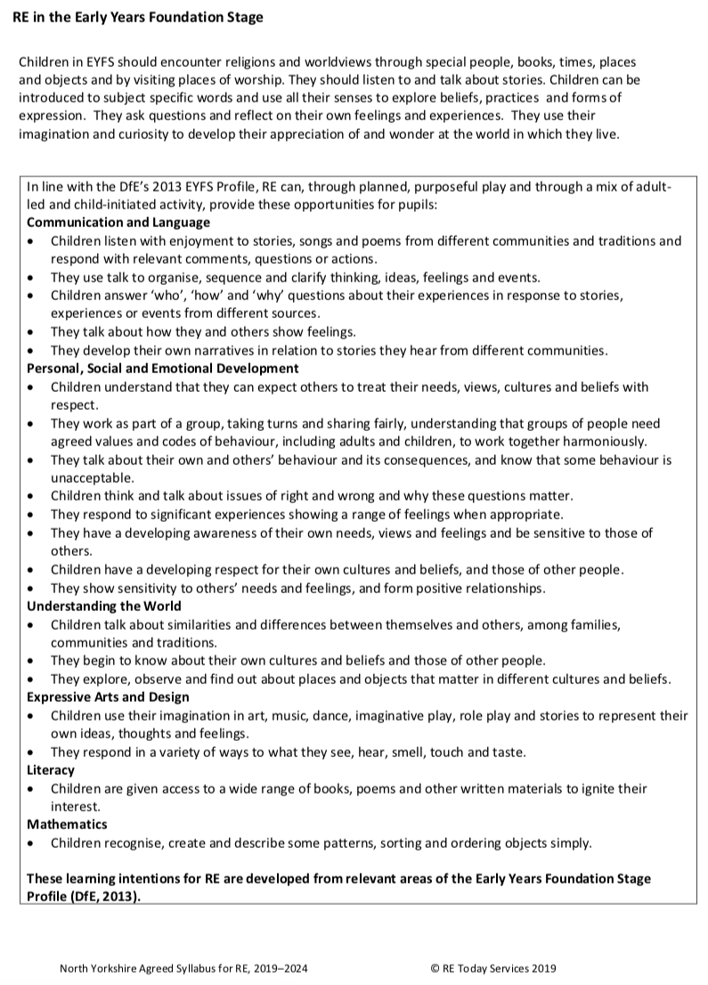
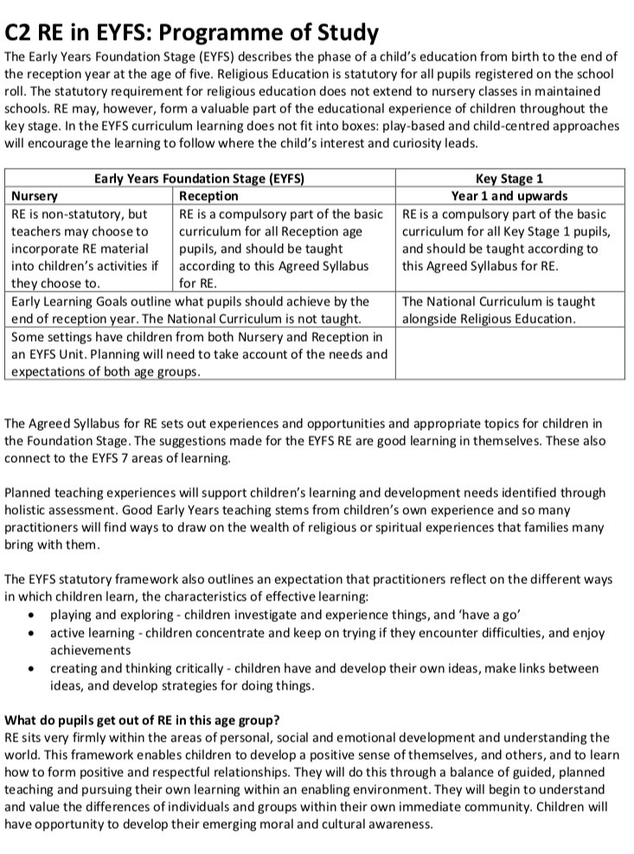

RE & The EYFS Development Matters 2021
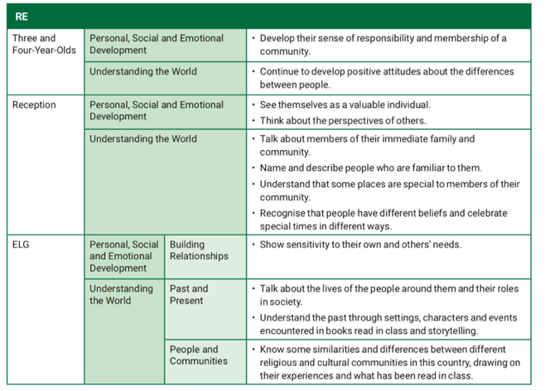

The characteristics of effective teaching and learning
In planning and guiding what children learn, practitioners must reflect on the different rates at which children are developing and adjust their practice appropriately. Three characteristics of effective teaching and learning are:
- playing and exploring - children investigate and experience things, and ‘have a go’
- active learning - children concentrate and keep on trying if they encounter difficulties, and enjoy achievements
- creating and thinking critically - children have and develop their own ideas, make links between ideas, and develop strategies for doing things
(Taken from the Statutory Framework for the EYFS)

Personal, Social and Emotional Development
Children’s personal, social and emotional development (PSED) is crucial for children to lead healthy and happy lives, and is fundamental to their cognitive development. Underpinning their personal development are the important attachments that shape their social world. Strong, warm and supportive relationships with adults enable children to learn how to understand their own feelings and those of others. Children should be supported to manage emotions, develop a positive sense of self, set themselves simple goals, have confidence in their own abilities, to persist and wait for what they want and direct attention as necessary. Through adult modelling and guidance, they will learn how to look after their bodies, including healthy eating, and manage personal needs independently. Through supported interaction with other children they learn how to make good friendships, co-operate and resolve conflicts peaceably. These attributes will provide a secure platform from which children can achieve at school and in later life.
(Taken from the EYFS Statutory Educational Programme)

Understanding the world
Understanding the world involves guiding children to make sense of their physical world and their community. The frequency and range of children’s personal experiences increases their knowledge and sense of the world around them – from visiting parks, libraries and museums to meeting important members of society such as police officers, nurses and firefighters. In addition, listening to a broad selection of stories, non-fiction, rhymes and poems will foster their understanding of our culturally, socially, technologically and ecologically diverse world. As well as building important knowledge, this extends their familiarity with words that support understanding across domains. Enriching and widening children’s vocabulary will support later reading comprehension.
(Taken from the EYFS Statutory Educational Programme)
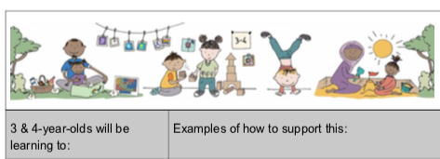

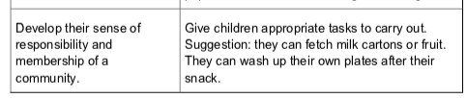

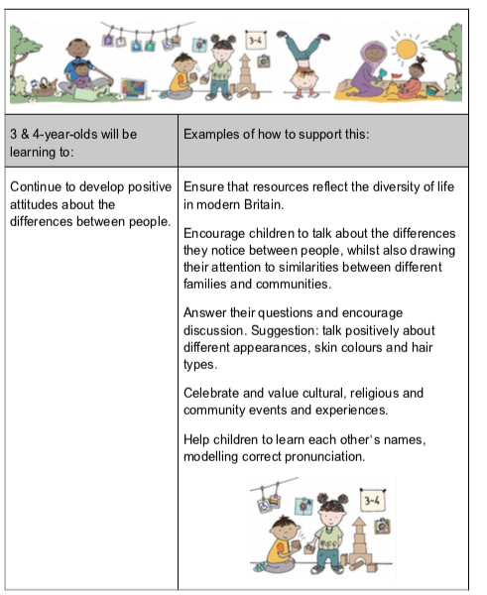

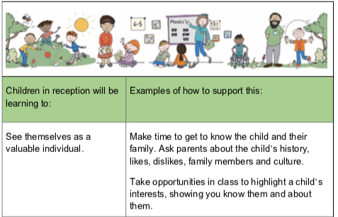

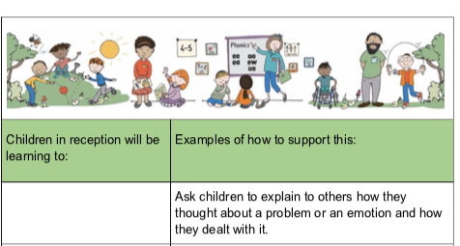

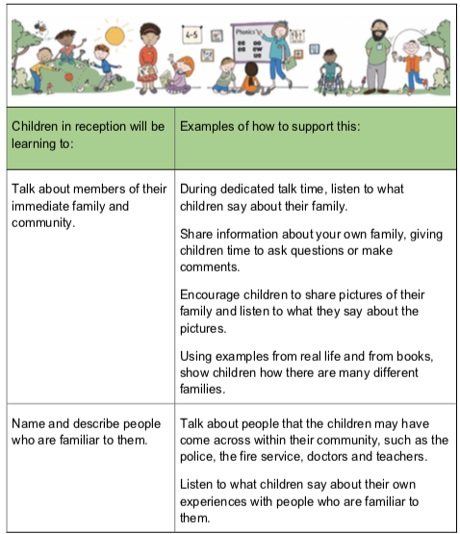

(Taken from the ‘Working with the revised Early Years Foundation Stage
Principles into Practice’ by JULIAN GRENIER’)

See EYFS Long Term Plan

