Autumn 1- History Knowledge Organiser Year 1 and 2
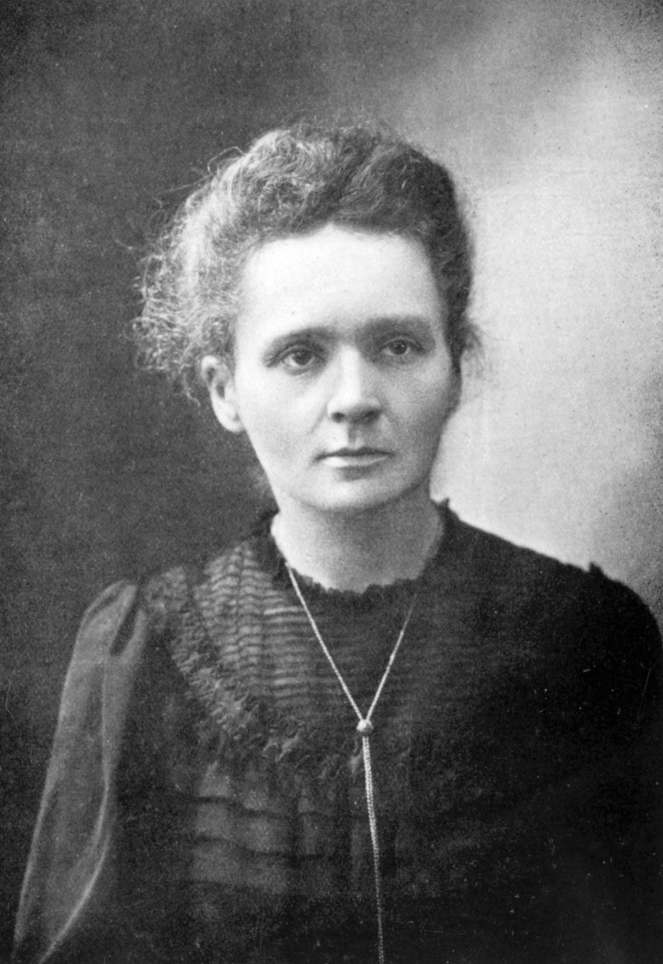
*How have the lives of significant Inventors throughout History shaped and influenced the lives and homes of people today?
1903 - Marie Curie discovered radium and polonium and invented the x – ray machine which was used to help soldiers during World War One. Her discoveries contributed to finding treatments for cancer. She was the first woman to ever receive the Nobel Prize for Physics!
Key Vocabulary
Invention – a new thing that someone has made
Inventor – someone who invents new ideas or methods on how to do things
Innovation – the introduction of something new
Pioneer – a person who is one of the first people to do something
Evolve – to develop, change or improve
Research - careful study and investigation for the purpose of discovering and explaining new knowledge
Electrical engineer- engineers who develop (think and make) different things that use electricity in a helpful way. They fix or design new and better ways of using devices
Lightbulb – a lightbulb produces light from electricity
Chemist – chemists study the substances that make up ‘matter’ – everything
Radioactivity – energy that moves from one place to another
Revolution -a sudden change
Industrial Revolution – over 200 years ago, this was a time of great change in the way products are made. It changed the way people lived as well as the way they worked. England was the first country in which these changes took place
X-ray – a powerful wave of energy. X-rays can show images, or pictures, of the inside of an object, such as a suitcase or the human body.
World War 1 – Fought between 1914- 1918. More than 8 million soldiers and sailors died. It was the largest war that the world had seen until that time and incredibly brutal, most of it fought in trenches.

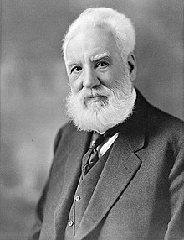
1876 -Alexander Graham Bell invented the telephone and made the very first telephone call! This revolutionised the way in which people communicate. Before this invention people had to communicate by letter or telegram!

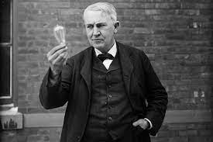
1879 – Thomas Edison invented the lightbulb, changing the way that people live their lives. Before the invention of the lightbulb, people had to use oil lamps, candles and gas street lamps to see once night fell.
Our Disciplinary Knowledge:
Photographs and Paintings
Photographs provide us with lots of clues as historians. Is the photograph black and white? What clothes are the subjects wearing? What can we see happening in the photograph? Photographs are a much more reliable source of evidence than paintings because a photograph is quite hard to change. A painter might not paint their subject exactly as they see it, they might add in something extra or not present a truthful vision of what they are looking at. This could happen for many reasons, so a historian has to consider these things when choosing whether or not to believe that everything in a painting is historically true.
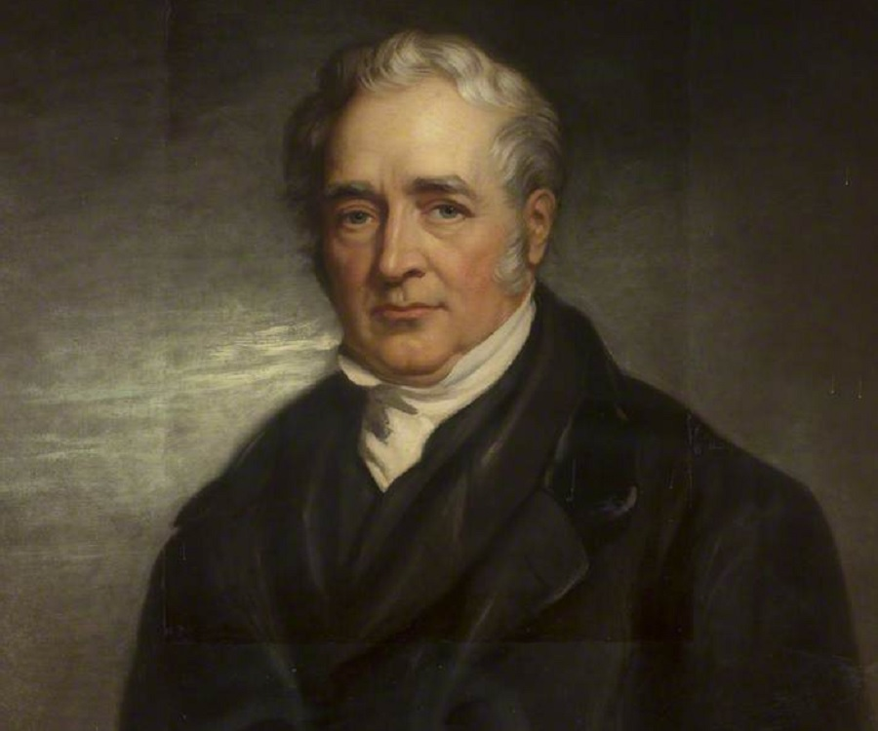
1814 – George Stephenson invented the first steam train, changing the way people transported materials and themselves. This invention helped to speed up the Industrial Revolution, which changed how we live and work forever!

