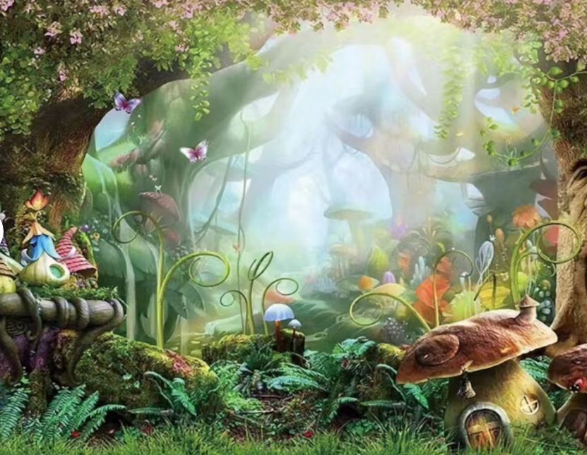
Summer 1- Literacy Knowledge Organiser
Fantasy Stories Year 1 and 2

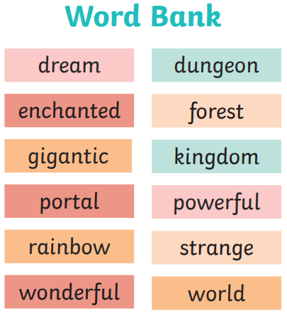

Fantasy story checklist
Did I write…
- A title?
- About a setting of an imaginary place?
- About magical characters?
- A problem
- A resolution
- An ending

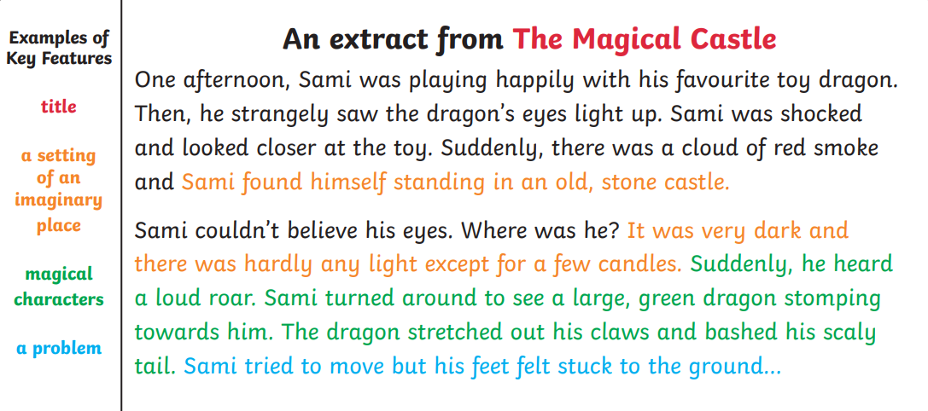

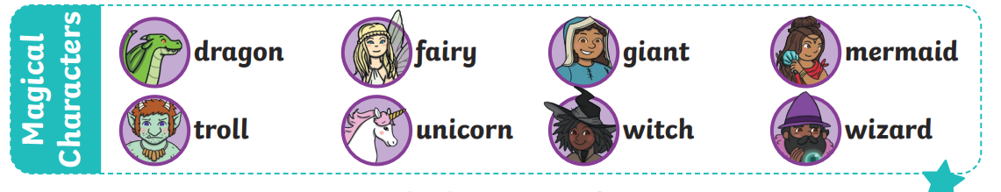

Expanded Noun Phrases
a magical castle that dark cave the dazzling lights

