Conkers Class (Reception) at Home Learning Activities
Summer 1 ‘Journeys into the Unknown’

Select from the following learning activities:
- In PSED, we are thinking about all of the important people in our lives… Can the children make a poster to show all of the people in their lives who help them?
- In Art, we are studying the artist Van Gogh, in particular his paintings of ‘The Starry Night’ and ‘Sunflowers’. The Reception children will create a collage representation of a sunflower. Van Gogh was famous for using bright colours and bold brushstrokes. Can the children find their own flowers to study before painting or drawing their own masterpieces?
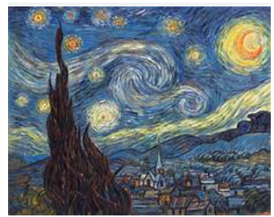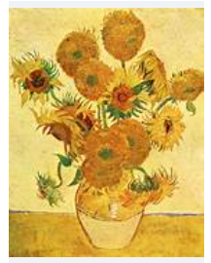
- In Maths this term, the children will focus on securing the numbers to 20. Can the children have a go at home counting aloud to 20 and practise writing all numerals to 20? If the children need a challenge, they could have a go at ordering numbers to 20!

We look forward to seeing all of your efforts in the week beginning Monday 20th May!

