Conkers Class (Year 1 and 2) at Home Learning Activities
Summer 1 ‘Journeys into the Unknown’

Select from the following learning activities:
- In PSED, we are thinking about all of the important people in our lives… Can the children make a scrap book of all the people in their family and write a sentence to describe them?
- In Art we are learning about the life and work of the artist Van Gogh, in particular his paintings of ‘The Starry Night’ and ‘Sunflowers’.
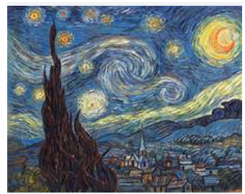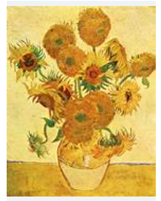
Van Gogh also painted many self-portraits. Can the children have a go at painting or drawing their own self portrait? Encourage children to use a mirror to note all of their facial features. Can the children name all of their features? Ensure they don’t miss any out!
- In History, we are studying Ancient Egypt and the discovery of Tutankhamun’s tomb. Using the attached hieroglyphics chart, can the children have a go at writing their name in hieroglyphics?
We look forward to seeing all of your efforts in the week beginning Monday 20th May!

