Summer 2- Design and Technology Knowledge Organiser Food Year 1 and 2
KS1 Cooking and Nutrition Aims
- To make healthy eating choices and understand a balanced diet
- To select their own ingredients for a food product
- To work in a safe and hygienic way
- To measure out ingredients by weight or quantity
- To present a food product in a way to impress the intended consumer
- To know where some of their food has come from
The Eatwell Plate
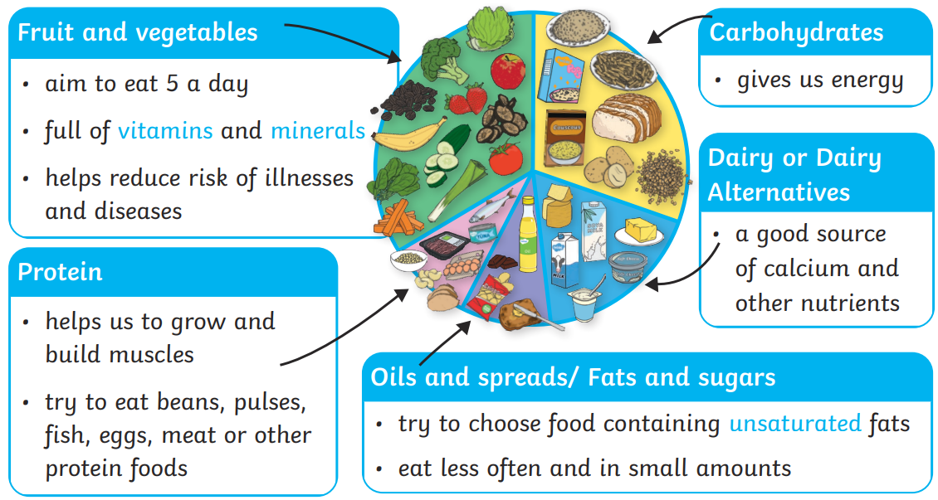



Vocabulary
Design – a plan showing how something is going to be carried out
Evaluate – to judge how good / bad something is
Senses – sight, sou
Texture – the look and feel of something
Appearance – how something looks
Protein – a kind of food that can help your body grow and stay healthy. Good examples are eggs, nuts, meat, beans, fish and meat
Dairy – food products that are made from animal milk
Carbohydrate- the body’s main source of energy found in foods like potatoes, bread and pasta
Balanced – not too much or too little of anything
Diet – what we eat
Hygiene

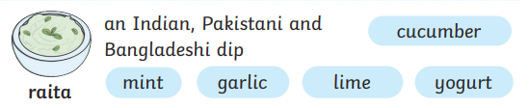
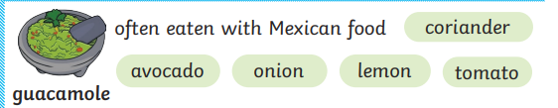
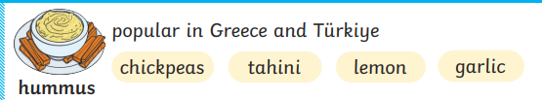

Food Hygiene Rules!
Tie long hair back! Roll up sleeves! Wash hands! Wipe all surfaces! Put apron on! Take off jewellery!

