Summer 2- History Knowledge Organiser Victoria and Elizabeth Year 1 and 2
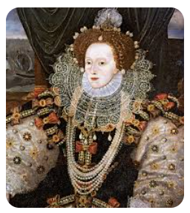
Monarch – a ruler, such as a king, queen or emperor
Royal – a king or queen and their family
Coronation – the ceremony of crowning a king or queen
Tudor – a time when kings and queens ruled in the fifteenth and sixteenth centuries
British Empire – all the places around the world that were once ruled by Britain
Parliament – the lawmaking group in the UK
Elizabethan – the time period when Queen Elizabeth 1 ruled
Victorian – the time period when Queen Victoria ruled
Catholic -the oldest and largest branch of Christianity
Protestant -a form of the Christian faith that began in the early sixteenth century
Invade – to enter a country by force in order to take control of it
Church of England – the leading Christian church in England
Defend - to protect from harm
Colony – a group of people from one country who build a settlement in another land
Conquer – to gain control of something through great effort
Legacy – something that is passed down or remembered from someone who came before
Armada – a Spanish word meaning a group of ships ready for battle
Sir Francis Drake – helped to build up England’s power during the reign of Queen Elizabeth 1
Phillip II – a powerful, Spanish king at the time of Queen Elizabeth I
The Golden Speech – a famous speech delivered by Queen Elizabeth I
Reign – a period of time that a king or queen rules over a country
Penny Post – the start of an affordable postal system under Queen Victoria
Prince Albert – Queen Victoria’s husband
The Great Exhibition – a famous exhibition during the Victorian age that showcased the art and inventions of England to the world

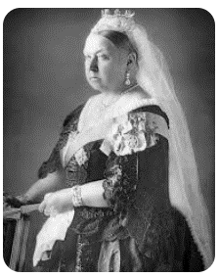

Core Knowledge
- Know about the role of a monarch
- Know about the journey to the throne of both Queen Victoria and Queen Elizabeth I
- Know about the similarities between both Queens: their long reigns, the cultural and economic flourishing during both reigns and the political stability during their reigns
- Know about the differences between both Queens: the religious climate of both eras, their global influence and the public perception of their marital status
- Know about how life in England changed between the reigns of Queen Elizabeth I and Queen Victoria
- Know about the enduring legacies of both Queens



