

**Why attendance matters…**

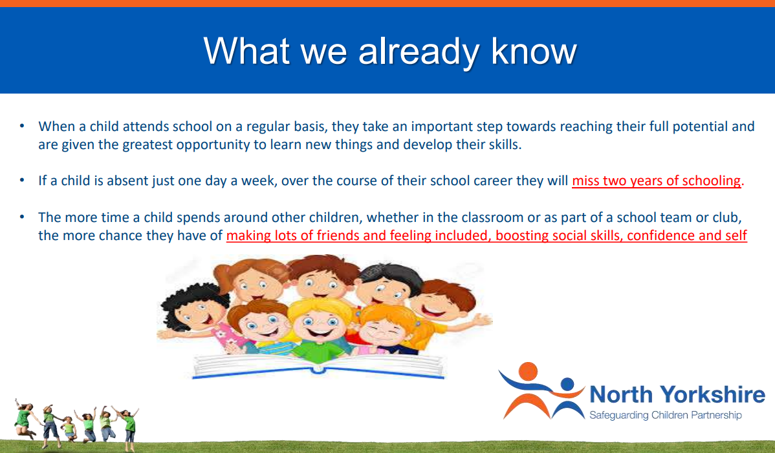

**Good attendance affirmations!**

Good attendance at school is not just about learning, it’s essential for your child’s wellbeing.

Good attendance will help your child make friends and develop social skills.

Good attendance will help your child learn life skills, team values and have fun.

Good attendance will support your child with a more well-rounded cultural awareness.

Good attendance will support your child in learning more about possible career pathways.

**Is my child too ill to go to school?**

**Unsure about whether to send your child to school?**

Please read this recent guidance from the NHS.

Is my child too ill for school? - NHS (www.nhs.uk)