
Health and Safety at Work etc. Act 1974

THIS IS THE HEALTH AND SAFETY STATEMENT OF

Leavening CP School

Our statement of intent is:

- Implement the requirements of NYC's Health and Safety Policy;

- to make adequate arrangements for the health, safety and welfare of staff and pupils;

- to provide adequate control of health and safety risks arising from our work activities;

- to consult with our employees on matters affecting their health and safety;

- co-operate with NYC in matters related to health and safety;

- to provide and maintain safe plant and equipment;

- to ensure safe handling and use of substances;

- to provide clear instructions, information, and supervision for employees;

- to ensure all employees are competent to do their tasks, and to give them adequate training;

- to prevent accidents and cases of work-related ill health;

- to maintain safe and healthy working conditions;

- provide personal protective equipment;

- implement emergency procedures, including evacuation in case of fire or other significant incident; and

- to review and revise this policy as necessary at regular intervals.

Signed: S. MITCHELL Headteacher

Signed:J. ROBINSON Chair of Governors

Date: September 2026

Review date: September 2027

HEALTH AND SAFETY POLICY

RESPONSIBILITIES

Overall responsibility for health and safety within the establishment is that of:
Mrs Sian Mitchell (Head Teacher)

Mr James Robinson (Chair of Governors)

Day-to-day responsibility for ensuring this policy is put into practice:
Mrs Sian Mitchell (Head Teacher)

To ensure health and safety standards are maintained/improved, the following people have responsibility in the following areas:

Name: Mrs Emma Isaacs
Responsibility: Health & Safety Governor

Name: Susie Kemp
Responsibility: School Administrator

Name: NYCC cleaning services
Responsibility: Caretaker
All employees have to:

- co-operate with supervisors and managers on health and safety matters;

- not interfere with anything provided to safeguard their health and safety;

- take reasonable care of their own health and safety and of others; and

- report all health and safety concerns to an appropriate person (as detailed in this policy statement).

The school has appointed a designated competent person as required by Regulation 7 of the Management of Health and Safety at Work Regulations 1999. The designated competent person is:

Dale Barton NYES Health and Safety Service
07788 564533

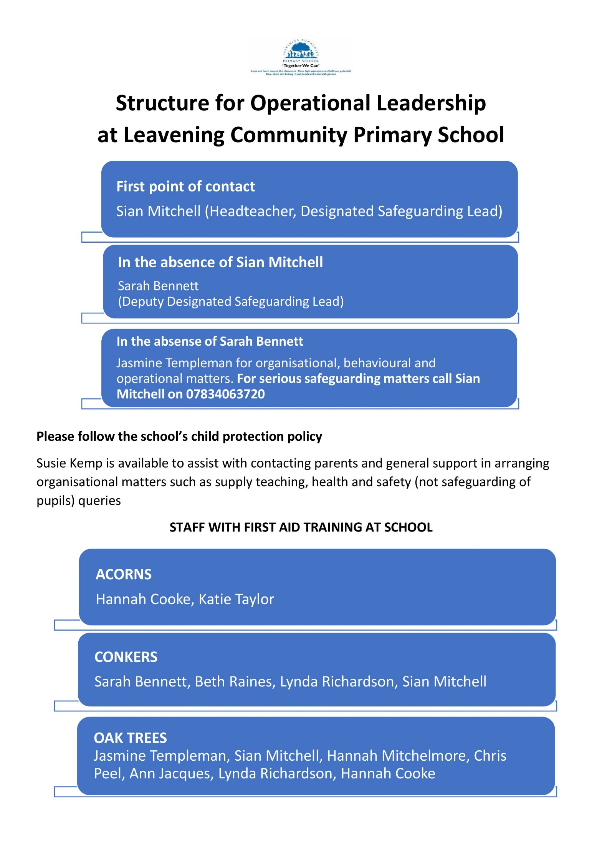
ORGANISATIONAL CHART

ARRANGEMENTS

HEALTH AND SAFETY RISKS ARISING FROM OUR WORK ACTIVITIES

Risk assessments will be undertaken by:

Mrs Sian Mitchell (Head Teacher)
and the staff member undertaking activity
The findings of the risk assessments will be reported to:

All staff

Action required to remove/control risks will be approved by:

Mrs Sian Mitchell (Head Teacher)
and the staff member undertaking activity
The person responsible for ensuring the action required is implemented is

Mrs Sian Mitchell (Head Teacher)
and the staff member undertaking activity
Checks that the implemented actions have removed/reduced the risks will be carried out by:

Mrs Sian Mitchell (Head Teacher)
and the staff member undertaking activity
Assessments will be reviewed:

In the event of an accident, annually or when the work activity changes, whichever is soonest.

ARRANGEMENTS

CONSULTATION WITH EMPLOYEES

Employee Representative(s) are:

N/A
Consultation with employees is provided by:

Agenda item on staff weekly meetings
Staff briefing and noticeboard
Training Days

ARRANGEMENTS

SAFE PLANT AND EQUIPMENT

Identifying equipment/plant, which will need maintenance is the responsibility of:

Mrs Sian Mitchell (Head Teacher)
NYES Property Solutions
NYES Cleaning
NYES Catering
Ensuring effective maintenance procedures are drawn up is the responsibility of:
Mrs Sian Mitchell (Head Teacher)
NYES Property Solutions
NYES Cleaning
NYES Catering
The person responsible for ensuring that all identified maintenance is implemented is:
Mrs Sian Mitchell (Head Teacher)
NYES Property Solutions
NYES Cleaning
NYES Catering
Problems with plant/equipment should be reported to:

Mrs Sian Mitchell (Head Teacher)
NYES Property Solutions
NYES Cleaning
NYES Catering
Checking plant and equipment health and safety standards before purchase is the responsibility of:
Mrs Sian Mitchell (Head Teacher)
NYES Property Solutions
NYES Cleaning
NYES Catering

ARRANGEMENTS

SAFE HANDLING AND USE OF SUBSTANCES

Identifying substances which need a COSHH assessment is the responsibility of:

Mrs Sian Mitchell (Head Teacher)
NYES Property Solutions
NYES Cleaning
NYES Catering
Grounds Maintenance
The person(s) responsible for undertaking COSHH assessments is/are:
Mrs Sian Mitchell (Head Teacher)
NYES Property Solutions
NYES Cleaning
NYES Catering
Grounds Maintenance
Ensuring that all actions identified in the assessments are implemented is the responsibility of:
Mrs Sian Mitchell (Head Teacher)
NYES Property Solutions
NYES Cleaning
NYES Catering
Grounds Maintenance
The person responsible for ensuring that relevant employees are informed about COSHH assessments is:
Mrs Sian Mitchell (Head Teacher)
NYES Property Solutions
NYES Cleaning
NYES Catering
Grounds Maintenance
Checking that substances can be used safely before they are purchased is the responsibility of:
Mrs Sian Mitchell (Head Teacher)
NYES Property Solutions
NYES Cleaning
NYES Catering
Grounds Maintenance
Assessments will be reviewed:

In the event of an accident, annually or when the work activity changes, whichever is soonest.

ARRANGEMENTS

INFORMATION, INSTRUCTION AND SUPERVISION

The Health and Safety Law poster is displayed at:

School office
Supervision of young workers and trainees will be arranged/ undertaken/monitored by:
Mrs Sian Mitchell (Head Teacher)

Ensuring that our employees working at locations under the control of other employers, are given relevant health and safety information is the responsibility of:

Mrs Sian Mitchell (Head Teacher)

ARRANGEMENTS

COMPETENCY FOR TASKS AND TRAINING

Induction training will be provided for all employees by:

Local SLT Induction
Mrs Sian Mitchell (Head Teacher)

Job specific training will be provided by:

NYC training dept.
Mrs Sian Mitchell (Head Teacher)
NYES Health and Safety Service
Health and Safety Training Requirements:

Asbestos/Legionella training
First Aid training
Fire Awareness / Fire Warden training

Working at Height / Safe Ladder use
Manual handling

Educational Visit Training
Training records are kept:

In Health & Safety Document Management file
Training will be identified, arranged and monitored by:

Mrs Sian Mitchell (Head Teacher)

ARRANGEMENTS

ACCIDENTS, INCIDENTS, FIRST AID AND WORK-RELATED ILL HEALTH
Locations of First Aid Boxes:

School office
Main corridor
Kitchen
Staff Room
The first aiders are:
All staff are emergency aid trained
All accidents and cases of work-related ill health are to be recorded in the accident book. The book is kept:

In the office
The person responsible for reporting accidents, diseases and dangerous occurrences to the NYC Health and Safety section is:

Mrs Sian Mitchell (Head Teacher)

ARRANGEMENTS

MONITORING

To check our working conditions, and ensure our safe working practices are being followed, we will undertake:

Legionnella testing
Asbestos inspection
Termly Visual H & S inspection
Establishment Hands Service Inspection
PAT testing
Fixed appliance electrical testing
Extraction fans maintenance
NYES Property Solutions Condition Survey
Prioritised programme of risk assessment
Boiler room annual inspection
Gulleys and Gutters checked and cleaned
Pest control
Sports and Gym equipment maintenance
The person responsible for investigating accidents is:

Mrs Sian Mitchell (Head Teacher)

The person responsible for investigating work-related causes of sickness absences is:

Mrs Sian Mitchell (Head Teacher)
NYC Occupational health
The person responsible for acting on investigation findings to prevent a recurrence is:

Mrs Sian Mitchell (Head Teacher)
NYC Occupational health

ARRANGEMENTS

ASBESTOS RISK MANAGEMENT

The Responsible Officer for asbestos management is:

Mrs Sian Mitchell (Head Teacher)

The Asbestos Risk Management file is kept in:

Admin Office
Site plans showing the location of asbestos containing materials (ACM’s) are kept in:

Admin Office
Ensuring that contractors are made aware of the location of ACM’s and that they sign the relevant permit to work is the responsibility of:
Mrs Sian Mitchell (Head Teacher)
and the Establishment Administrator
Asbestos risk assessments will be undertaken by:

Mrs Sian Mitchell (Head Teacher)

Visual inspections of the condition of ACM’s will be undertaken by:

NYCC services (Caretaker)

Records of the above inspections will be kept in:

Admin Office

ARRANGEMENTS

LEGIONELLOSIS MINIMISATION

The two ‘Nominated Persons’ for Water Management at the premises are:

Mrs Sian Mitchell (Head Teacher)
NYCC services (Caretaker)

Risk assessments detailing on-site tasks for the minimisation of Legionellosis risk are kept in:

Water Management Arrangements Folder
The person responsible for carrying out the on-site tasks set out in the above assessments is:

Mrs Sian Mitchell (Head Teacher)
NYCC services (Caretaker)

Record showing that the above on-site tasks have been undertaken are kept in:

Water Management Arrangements Folder
Admin office

ARRANGEMENTS

WORK AT HEIGHT

All work at height in the establishment must be authorised by:

Mrs Sian Mitchell (Head Teacher)

Risk assessments for working at height are to be completed by:

Mrs Sian Mitchell (Head Teacher)
and all members of staff
Equipment used for work at height is to be checked by and records kept in:

Establishment Governor  Mrs Emma Isaacs | Establishment Management File  Admin office

ARRANGEMENTS

MANUAL HANDLING

All manual handling tasks in the establishment must be authorised by:

Mrs Sian Mitchell (Head Teacher)

Risk assessments for manual handling tasks are to be completed by:

Mrs Sian Mitchell (Head Teacher)
and all members of staff
Equipment used for manual handling is to be checked by and records kept in:

Establishment Governor  Mrs Emma Isaacs | Establishment Management File  Admin office

Risk assessments for manual handling tasks are to be completed by:

Mrs Sian Mitchell (Head Teacher)
and all members of staff

ARRANGEMENTS

EDUCATIONAL VISITS

Off-site educational visits must be authorised by:

NYC, Mrs Sian Mitchell (Head Teacher) and Governors
The Educational Visits Co-ordinator(s) is/are:

Mrs Sian Mitchell (Head Teacher)

Risk assessments for off-site visits are to be completed by:

Group Leader
NYC Policy, Procedures & Guidance for Educational Visits are kept in:

Admin office
Details of off-site activities are to be logged onto Evolve by:

Mrs Sarah Bennett, Educational Visits Co-ordinator

ARRANGEMENTS

EMERGENCY PROCEDURES – FIRE AND EVACUATION

The person responsible for ensuring that the fire risk assessment is undertaken and implemented is:

Mrs Sian Mitchell (Head Teacher)

Escape routes are checked by/every:

All staff | Daily
Fire extinguishers are maintained and checked by/every:
Walker Fire  Visually Inspected | Annually  Termly
Alarms are tested by/every:

NYCC services (Caretaker)  Monks | Weekly  Bi-Annually
Emergency evacuation will be tested:

Termly

APPENDICES

List here any other policies relevant to health and safety e.g. Medicines Policy, Educational Visits Policy etc.
CYPS Policy and Guidance Handbook
Emergency Response Guide
Safeguarding Policy
Safeguarding Audit
Lockdown Procedure
Disaster Recovery Procedure
Educational Visits Policy
Display Screen Equipment Procedure
Emergency Procedures
Events Procedure
Fire Safety Procedure
First Aid and Medicines Procedures
First Aid at Work Procedure
Intimate Care Procedure
Laptop and Tablet Procedure
Lettings Procedure
Lone Working Procedure
Medicines Policy
Midday Supervisor Procedure
Missing Child Procedure
Nappy Changing Procedure
Snow and Ice Procedure
Gritting Plan
Use of Chemicals at Work Procedure
Use of Sunscreens Procedure
Working at Height Procedure

